**Draft**

**2014**

**Town Center Plan**

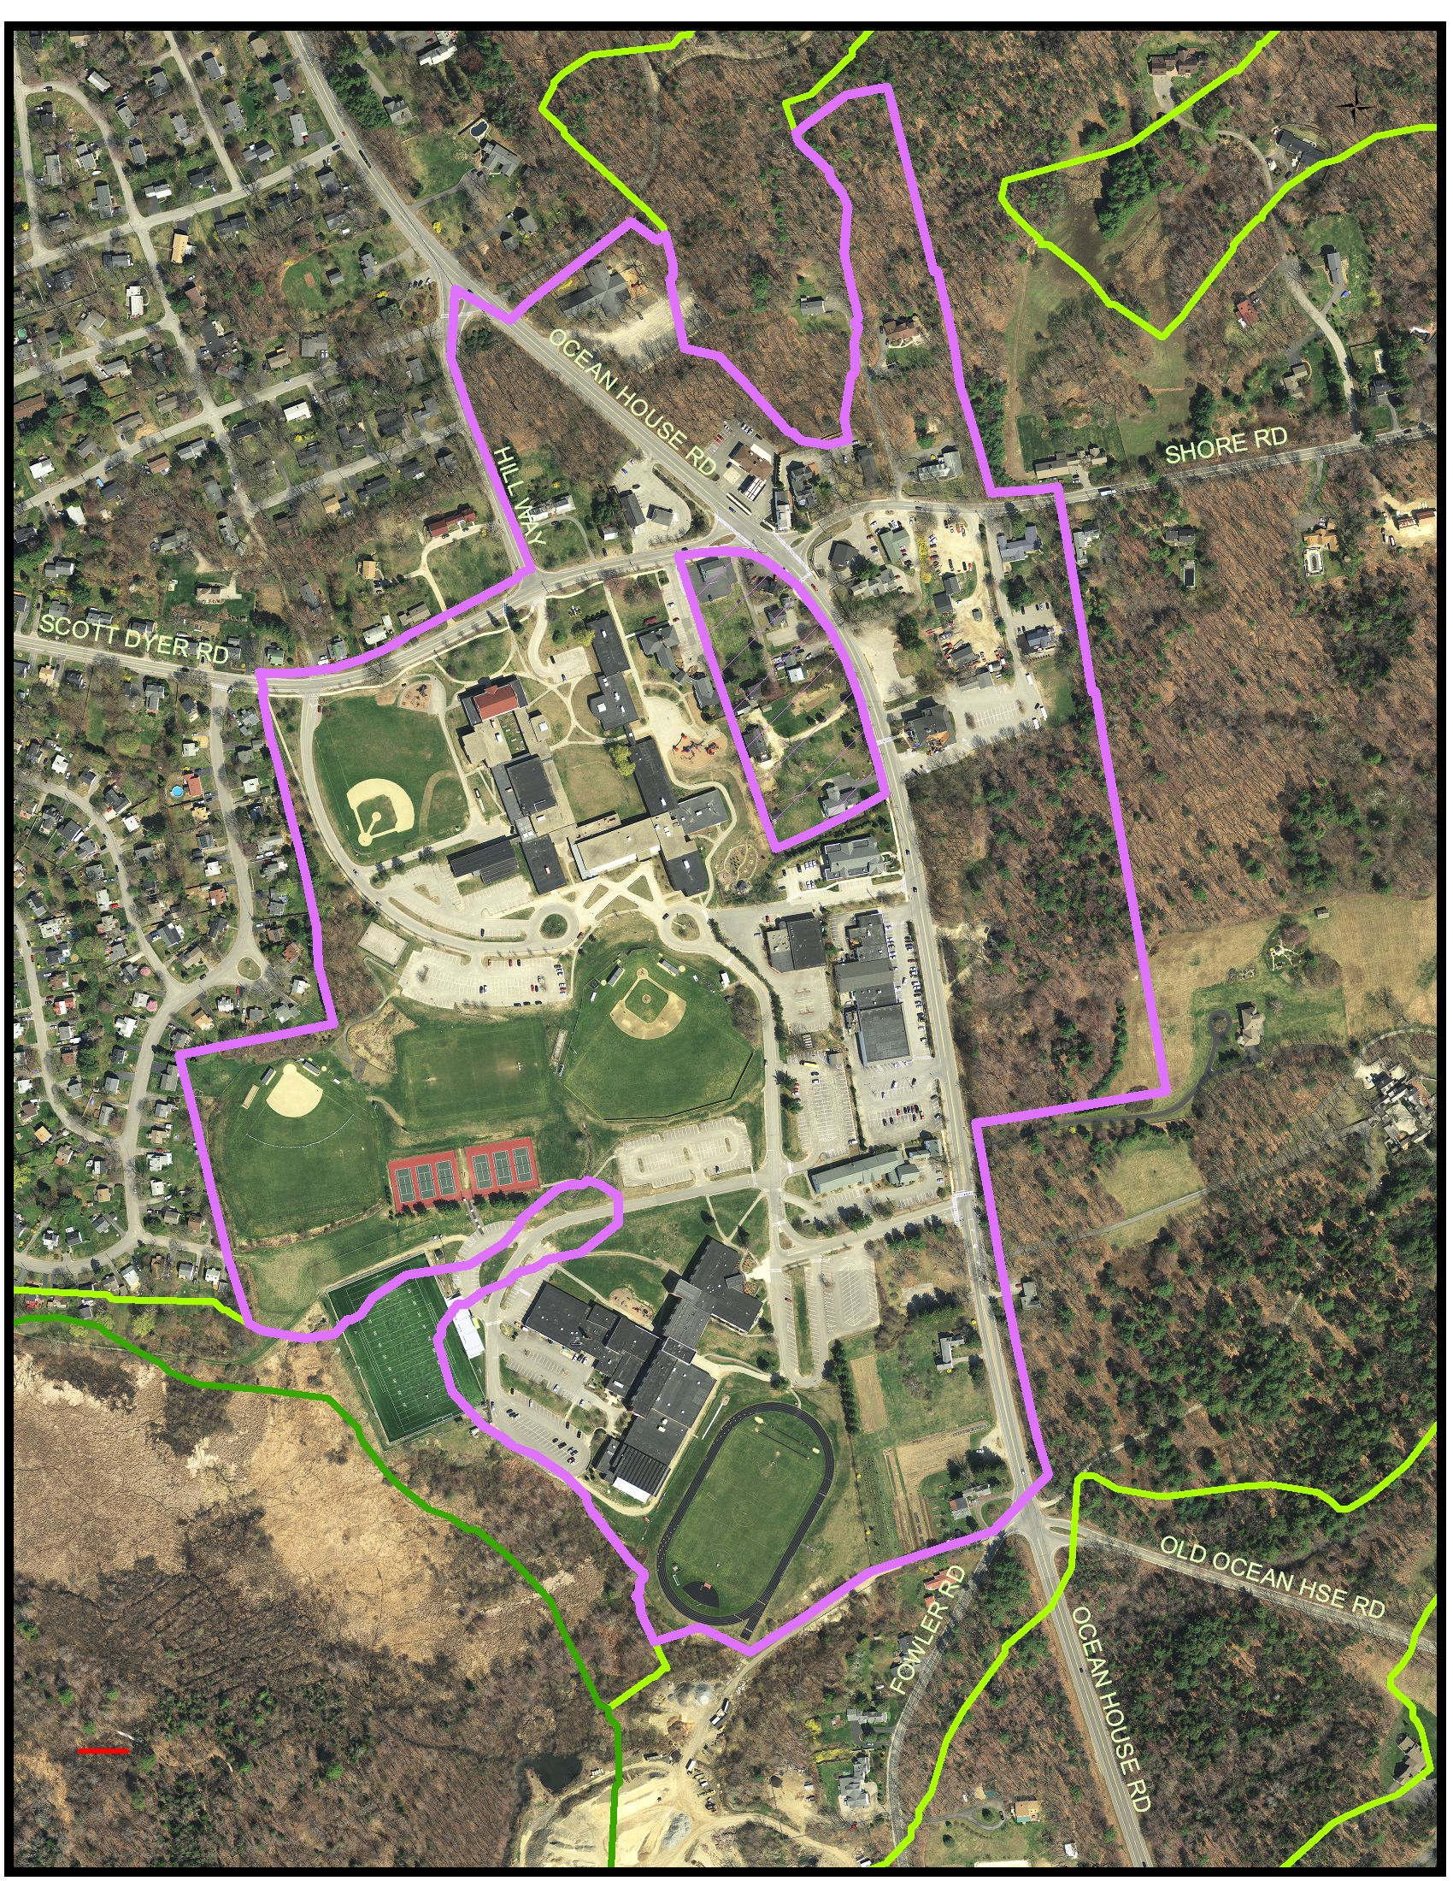

**5-28-2013Town Center Plan Committee**

Stephanie Carver, Chair

Peter Curry, Planning Board representative

Diane Hessler, public representative*

Skip Murray, Town business owner representative

Stephen Parkhurst, public representative

Lee Rutty, public representative

David Sherman, Town Council

Mary Townsend, School Board*

Jamie Wagner, Town Council

*Resigned from committee December, 2013

Staff

Maureen O’Meara, Town Planner

**Table of Contents**

Executive Summary 4

Vision and Goals 5

Recommendations 6

Appendices:

Appendix A: Town Council Charge to the Committee 14

Appendix B: Map of the Town Center Zone 16

Appendix C: Evolution of the Town Center from 1993- 2014 17

Appendix D: Public Participation Process 19

Public Forum Minutes, October 17, 2013 20

Town Center Questionnaire Summary Report 26

Appendix E: Town Center Existing Properties Spreadsheet 66

Appendix F: Town Center Infrastructure 67

Appendix G: Village Green Concept Plan 72

Appendix H: Sample Zoning Ordinance Text Amendment 73

Appendix I: Reference Materials 74

**Executive Summary**

The Town Center Plan Committee is pleased to submit this final report to complete the committee’s charge. The Town Council appointed the 9-member Town Center Plan Committee, which held 17 meetings, including a site walk of the Town Center, a joint meeting with the Library Planning Committee and a public forum on October 17, 2013. All meeting agendas and minutes were posted on the town website. The committee solicited public comment at each of its meetings and also with a questionnaire.

The committee reviewed the 1993 Town Center Plan and is proposing an updated plan with 5 goals. The goals continue the direction of the original plan. They include promoting pedestrian safety, recognizing the Town Center’s status as the central commercial area, creating a village green and other community gathering places, improving visual appeal and developing infrastructure financing.

From these goals, the committee is making 7 recommendations, the small number reflecting the sharper focus of this Town Center Plan. The committee recognizes that financial constraints were the chief obstacle to a fuller implementation of the 1993 plan. Consequently, this plan includes specific recommendations to finance infrastructure improvements and to be open to public/private partnership opportunities.

The committee recommendations reflect the Town Center’s status as a mid-level priority. Residents would like the Town Center to be a gathering place, pedestrian-friendly and attractive, but they do not want to divert resources from higher priorities such as open space and schools. The plan recommendations are therefore structured for incremental implementation as resources and opportunities become available.

The committee acknowledges that many of the properties in the Town Center are privately owned. As a result, the town must sometimes react to the decisions of private property owners, and cannot dictate the disposition of private property that otherwise complies with town regulations.

One of the most immediate opportunities for improvement in the Town Center is the proposal to renovate the library. The committee agrees that the library should be located in the Town Center and should be consistent with the Town Center goals and recommendations, specifically promoting community gathering places.

The committee looks forward to reviewing its recommendations with the Town Council.

**VISION**

To create an identifiable, vibrant town center that includes mixed retail uses for residents and visitors, a safe and inviting pedestrian and bicycle environment, a common meeting place, visual vitality, and linkages to the town’s open space and nearby residential neighborhoods.

**GOALS**

•**Pedestrian and vehicular circulation**. Promote safe pedestrian, bicycle and vehicular circulation in the town center, with an emphasis on completing the sidewalk network throughout the Town Center and connecting to nearby neighborhoods.

• **Primary Commercial Area**. Support the Town Center as the primary location for new commercial development in Cape Elizabeth and encourage a modest amount of small-scale, mixed use development.

•**Gathering Places**. Create a town green and encourage small commercial establishments (such as coffee shops or restaurants) that provide opportunities for community members to come together.

•**Visual Appeal**. Improve the appearance and identity of the Town Center through continued application of the Town Center design standards to new development and formalizing the design standards for infrastructure improvements.

•**Infrastructure Financing**. Further investigate, and if appropriate, implement alternative financing tools to fund town center infrastructure improvements in a manner that moderates fiscal impacts on other town priorities.

**RECOMMENDATIONS**

The following recommendations are listed in corresponding order with the goals in the previous section. Recommendations are intended to be an umbrella under which a variety of implementation steps would fit. Each recommendation includes background information, a description of the recommendation and a cost estimate. High-level, ballpark estimates are provided to give the Town Center Plan context and will need to be refined as recommendations are implemented. Cost estimates were provided by Steve Harding, Town Engineer, at Amec Environment and Infrastructure, Inc.

**Goal: Pedestrian and Vehicular Circulation**

**1.** Improve and expand pedestrian and bicycle safety and connectivity of sidewalks and paths within the Town Center and to nearby neighborhoods.

Background: In the late 1990’s, the Town obtained grant funding to build and rebuild sidewalks from Scott Dyer Rd/Longfellow Drive to the Pond Cove Shopping Center on Route 77. Additional sidewalk construction has occurred in the Town Center and the Shore Road Path was constructed in 2011. (See Appendix F for more information on existing and proposed sidewalks.)

Recommendation Description: This recommendation would complete the sidewalk network throughout the Town Center. Additional sidewalk connections to nearby neighborhoods would also be pursued. Less formal paths within the Town Center, including greenbelt connections to Robinson Woods and the Spurwink Marsh, and a path from Route 77 to the library, would be evaluated, constructed, improved and/or maintained. Pedestrian safety in the Town Center is a priority, including at the Route 77/Shore Rd/Scott Dyer Rd intersection. Preservation of existing biking infrastructure and expansion of biking infrastructure when appropriate should also be considered.

Cost Estimate: $1 million Town Center sidewalks

$1.7 million Town Center/neighborhood connector sidewalks

**2.** Recast Route 77 in the Town Center as Cape Elizabeth’s “main street.”

Background: Route 77, or Ocean House Rd, is a state highway, but within the confines of the Town Center, it is also Cape Elizabeth’s main street. Increased pedestrian traffic and slower vehicle speeds are more consistent with the function of a main street. Greater impact on vehicle speed can be accomplished with a “main street” design that includes sidewalks separated from the road with grassed esplanades planted with street trees and new buildings that are pulled closer to the road with parking to the side or rear. These design features are already included in the Town Center regulations. Access management techniques such as reducing curb cuts, sharing curb cuts between abutting properties and moderating the width of curb cuts are also part of the Town Center regulations.

Recommendation Description: It is now time for the Maine Department of Transportation (MDOT) classification of the section of Route 77 in the Town Center to be changed from arterial to a lesser classification more consistent with a main street in order to reduce the maximum speed allowed. The Town should advocate for this change with the MDOT. The Town’s effort should include documentation of the Town Center Zone requirements, plans for pedestrian improvements, existing uses information emphasizing the community facilities clustered in the Town Center and other relevant information.

Cost Estimate: In-house staff time, possible consultant technical support

**Goal: Primary Commercial Area**

**3.** Update the Town Center Stormwater Management Study and plan for construction of needed stormwater improvements.

Background: In 1995, the Town received grant funding to prepare a stormwater management plan for the Town Center. The plan called for collection of stormwater from roadways and lots located in Town Center into a stormwater system. The system would be collected in underground piping and outlet through the school campus underground stormwater collection system and then to the Spurwink Marsh. Some of the stormwater collection system has been constructed, but the system remains unfinished and is a potential costly obstacle to property owners in the Town Center when improving their property. A formal stormwater collection system allows the small lots in the Town Center to fully utilize the lot rather than consider onsite detention basins.

Recommendation Description: The 1995 plan should be reviewed and updated, both with improvements already constructed and with integration of Low Impact Development (LID) techniques as appropriate. The study should be prepared by a professional engineer working with town staff. Seventy-five percent of the 1995 study was funded with a grant and town staff should be directed to pursue grant funding for the update.

Cost Estimate: $20,000 for consulting engineer, in-house staff

**Goal: Gathering Places**

**4.** Consider creating a town green or common open space within the town center.

Background: Both the 1993 Town Center Plan and the feedback received by the Town Center Plan Committee (2013) support the creation of a town green in the Town Center. This town open space should be a place for residents to visit when doing business in the Town Center, for passive relaxation and for the community to come together during events. The village green should be highly visible, ideally with frontage on Route 77. If traditionally designed, the village green should be framed with buildings distinctive due to their purpose and/or architecture (one example is the Town Hall). The 1993 Plan included concept schemes showing a potential village green in multiple locations and recommended that the village green be in the area of the Town Hall and Pond Cove Shopping Center. This plan was incorporated by reference into the 2007 Comprehensive Plan.

There are potentially multiple locations in the Town Center where a village green would be appropriate. Purchase of land in the Town Center to create a village green, however, is not a high priority for open space preservation or as a capital improvement (See FOSP Report and Annual CIP Budget).

Recommendation Description: The committee repeats the recommendation from the 1993 plan to consider creating a village green. As with other recommendations in the 1993 plan, the lack of funding has been an obstacle to creating a town green. For this reason, absent available funding or the likelihood that funding will become available, the committee recommends that the town pursue public/private partnership opportunities where the cost of creating a village green can be reduced and the town’s overall Town Center goals are met.

For example, the owner of the parcel of land located south of the Town Hall presented the committee with a *concept* plan where development of the property could include a public village green of approximately 1 acre in size. (See Appendix G, Village Green Concept Plan) While the property can be developed without a village green, the green adds to the desirability of the potential development and advances town goals. The property includes a small (less than one-tenth of an acre) RP2 wetland near its center, which could be incorporated into a water element on the village green. In order to signal support for the village green development concept, the Town should consider adoption of an amendment to the Town Center District that makes it clear that alteration of an RP2 wetland in the Town Center District would be acceptable where a substantial public benefit is created. (See Appendix H, Sample Zoning Ordinance Text Amendment)

Cost Estimate: In-house staff time

**Goal: Visual Appeal**

**5.** Maintain the current design standards that promote a pedestrian-friendly town center and quality design that contributes to a sense of place.

Background: The 1993 Town Center Plan recommended that a new Town Center Zoning District be created and that the district include design standards requiring new development to be built consistent with the Town Center purpose. The zoning district and design standards were adopted in 1995 and the town’s experience with the zoning has been positive.

In 2002, the Town Council reviewed the requirement that new development in the Town Center include a sidewalk along the frontage of the property. The Town Council concluded that this policy was beneficial in extending the sidewalk network in the absence of public funding for construction.

The design requirements establish a “build to” line for new construction and restrict parking to the side or rear of a building. Building standards are established that require high quality finish materials and compatibility with historic structures, including additions or alterations to historic structures. Below is a list of locally historic town center structures:

1235 Shore Rd, Stick Style, C. 1875-1890

312 Ocean House Rd, Italianate, c. 1855-1875 (Murray House) 320 Ocean House Rd, Colonial Revival, built 1901, rebuilt 1948 (Town Hall)

343 Ocean House Rd, Greek Revival, c. 1840-1870

351 Ocean House Rd, Greek Revival, c. 1840-1870

359 Ocean House Rd, Italianate, c. 1860-1885

11 Hill Way, Colonial Revival/Gothic, late 19th C

Hill Way, Barn, late 19th -early 20th C

Scott Dyer Rd, Thomas Memorial Library-Pond Cove School Section, Colonial Revival, 1912

Scott Dyer Rd, Thomas Memorial Library-Spurwink section, Italianate, c. 1875-1885

Scott Dyer Rd, Middle School, Colonial Revival, 1933

Site design standards require special attention to the area between the road and the front of the building. These landscaping standards, combined with the building standards, serve not only to promote high-quality development in the town center, but also assure appropriate treatment of gateway properties located on the north and south ends of Route 77.

Recommendation Description: The Town Center Plan Committee discussed the existing zoning standards, including the sidewalk requirement. The committee invited Mike Concannon, owner and developer of 349 Ocean House Rd, to make a presentation from the developer’s perspective. Mr. Concannon acknowledged that sidewalk and lighting construction requirements added to his costs, but he would not recommend eliminating the requirements. He is confident the improvements will add to his property’s appeal and to the appearance of the Town Center. Sidewalks remain popular with residents. (See Appendix D, Public Participation Plan/Town Center Questionnaire Summary Report) The committee is recommending that the intent and scope of the current standards be retained, which does not mean that adjustments might not be considered as appropriate.

Cost Estimate: 0

**6.** Formalize design standards for town center infrastructure, including but not limited to sidewalk width and surface materials, street trees, lighting fixtures, and seasonal promotional materials.

Background: Following the sidewalk construction project in the 1990’s, town staff informally established a standard width and surface treatment for sidewalks to complement the standards in the Town Center design requirements.

Recommendation Description: Because infrastructure improvements are occurring incrementally, standard technical specifications are needed to create a consistent visual identity for the Town Center. These specifications should be collected, completed where needed, and adopted. Standards should include but not be limited to sidewalk width and surface treatment, lighting fixtures, signage, banners, street trees, etc.

Cost Estimate: $5,000 - $10,000 technical consultant

**Goal: Infrastructure financing**

**7.** Develop funding strategies, including but not limited to a Tax Increment Financing (TIF) District for the Town Center, to fund infrastructure improvements.

Background: The 1993 Town Center Plan included recommendations for construction of sidewalks throughout the Town Center, creation of a village green, a stormwater management system, and other improvements. Most of these improvements have not been completed due to a lack of funding. Some sidewalk connections and stormwater improvements were designed but not built due to a lack of construction funding. Many of these same improvements are now recommended as part of this Town Center Plan, but the outlook for municipal funding at this time remains the same.

Tax Increment Financing (TIF) is a tool provided under state law to allow a municipality to shelter new property tax revenues for the purpose of improving commercial areas. The TIF application, which must be submitted for state approval, must designate a specific location where the TIF applies and the purpose of collecting TIF revenues.

In Cape Elizabeth, the Town Center could be designated a TIF District. Any increase in tax revenues, or a portion of it, collected in the Town Center would be dedicated to infrastructure improvements within the Town Center. The increase in property values in the Town Center would also be sheltered from inclusion in state municipal revenue sharing, state aid to education and county tax calculations.

This is an ideal time for the town to consider a Town Center TIF because of the amount of property currently in transition and the likelihood that those properties will be improved and increase in value. A TIF District implemented in 2015 would set the base property value of the district at its April 1, 2014 value.

How much in revenues could be generated and what impact would that have on total tax revenues? In order to further explore how a TIF might work, the following table estimates how a Town Center TIF would have functioned from 2003-2013. The Town Center is 144 acres and in 2003 had a total property valuation of $60,761,400. From the period 2003-2013, $867,300 in property value was added in the Town Center, as shown in the table below. (This number has been adjusted to factor out increases due to the 2011 revaluation.)

|  |  |  |  |
| --- | --- | --- | --- |
|  |  | Value Added | Annual |
| Year | Tax Rate | from Base year | Tax Revenue |
|  |  |  |  |
| 2003 | 22.64 | 508900 | 11,521.50 |
| 2004 | 14.2 | 508900 | 7,226.38 |
| 2005 | 15.34 | 508900 | 7,806.53 |
| 2006 | 15.92 | 508900 | 8,101.69 |
| 2007 | 16.16 | 419900 | 6,785.58 |
| 2008 | 16.46 | 419900 | 6,911.55 |
| 2009 | 17.44 | 656000 | 11,440.64 |
| 2010 | 17.54 | 792900 | 13,907.47 |
| 2011 | 17.86 | 792900 | 14,161.19 |
| 2012 | 15.18 | 792900 | 12,036.22 |
| 2013 | 15.84 | 867300 | 13,738.03 |
|  |  |  |  |
|  |  |  | 113,636.78 |

If a TIF had been established in 2003, tax revenues of approximately $113,600 would have accrued over a ten year period. These funds would have been available to pay for Town Center infrastructure improvements.

With the amount of property in transition in the Town Center, it is likely that some new development will occur. How would new investment impact a Town Center TIF? The chart below builds upon the 2003-2013 Town Center property value data above. The “New Investment scenario” assumes that, over a 10 year period, two projects were constructed in the Town Center, adding $500,000 and $400,000 in value. With this scenario, the increase in tax revenues would be almost $200,000.

|  |  |  |  |
| --- | --- | --- | --- |
|  |  | New Investment | Scenario |
| Year | Tax Rate | Scenario | Tax Revenue |
|  |  |  |  |
| 2003 | 22.64 | 508900 | 11,521.50 |
| 2004 | 14.2 | 508900 | 7,226.38 |
| 2005 | 15.34 | 508900 | 7,806.53 |
| 2006 | 15.92 | 1008900 | 16,061.69 |
| 2007 | 16.16 | 919900 | 14,865.58 |
| 2008 | 16.46 | 919900 | 15,141.55 |
| 2009 | 17.44 | 1156000 | 20,160.64 |
| 2010 | 17.54 | 1292900 | 22,677.47 |
| 2011 | 17.86 | 1692900 | 30,235.19 |
| 2012 | 15.18 | 1692900 | 25,698.22 |
| 2013 | 15.84 | 1767300 | 27,994.03 |
|  |  |  |  |
|  |  |  | 199,388.78 |

During the same 2003-2013 time period, the increase in property value would have been sheltered from inclusion in state municipal revenue sharing, state aid to education, and Cumberland County taxes. The total property valuation of the Town of Cape Elizabeth is used to calculate how much state revenue sharing and state aid to education that the state will provide to the town. More property value reduces state payments. More property value also increases the town’s percentage of county taxes. With a Town Center TIF, the increase in property value in the Town Center would not be included in the total town valuation for either state revenue or county tax calculations. For example, in 2013, with $867,300 of Town Center value sheltered, state revenue sharing and aid to education would increase approximately $8,000 and county tax avoided would be about $600. Stated another way, without a Town Center TIF in 2013, of the $13,700 in tax revenue collected from new Town Center value, only $5,100 (or 37%) remains with the town. The rest is “lost” to state and county valuation adjustments.

The above estimates are a concept level analysis. An actual TIF district would require more refined numbers and TIF districts typically extend 20 years. TIF funds must be segregated for improvements in the district or outside the district as long as they are related to the district. While projected TIF revenues would not be sufficient to fund all or most of Town Center infrastructure needs, they could be the local match for grant applications that close the funding gap. By state law, TIF funds cannot be used for municipal or school buildings, however, by sheltering the increase in property value, there remains revenue advantages for municipal and school revenues.

Another funding strategy is the Infrastructure Improvement Fund established by the Town. This is a town account which is funded from $3/$1,000 of the $10/$1,000 fee for building permits. The fund is dependent on development activity. The fund currently has a $130,000 balance. This fund has been used to partially fund infrastructure in the Town Center in the past.

The Town has also been successful in competing for grant funding. Some of the funding sources with potential for the Town Center include Safe Routes to School grants, Coastal Zone Management funds, and the MDOT Municipal Partnership Initiative.

Recommendation Description: In order to move this Town Center Plan forward, new financing strategies should be considered. These strategies should recognize the Town Center’s status as a mid-level priority, that is, an area that residents would like to be a gathering place, pedestrian friendly and attractive, but for which they do not want to divert resources from higher priorities such as open space and schools. The Town should consider how potential financing strategies impact school and municipal budgets. The Town should also be prepared to take advantage of grant funding opportunities when they are available.

Cost Estimate: In-house staff, consultant support as needed.

**Appendix A**

**Town Council Charge to the Committee**

The Cape Elizabeth Town Council created the Town Center Plan Committee with the following charge in January, 2013.

**Charge**

**Town Center Plan Committee 2013**

**Introduction**

Cape Elizabeth adopted a Town Center Planning in 1993 and subsequent zoning amendments in 1995. It is time to revisit the plan and take a fresh look at the Town Center with the goal to support a vibrant, business and pedestrian friendly town center. The committee should complete its recommendations by the end of 2013.

**Committee Structure**

The 2013 Town Center Committee shall consist of 9 members. The Town Council, following a recommendation from the Appointments Committee, shall appoint 5 residents, of which at least one shall be a town center business owner and one a resident of the town center or an adjacent neighborhood. The Town Council shall appoint 2 of its members to serve on the committee and shall ask the Planning Board and the School Board to also appoint one of its members to the committee. The committee shall appoint its own chair and shall keep minutes of the meetings. The Town Manager shall designate staff for the committee.

**Committee Charge**

1. The Town Center Plan Committee shall review existing conditions in the town center, including but not limited to land uses, lot and building vacancies, infrastructure (roads, sidewalks, stormwater, sanitary sewer, etc), but not including municipal buildings.

2. The committee shall meet with the library planning committee to consider opportunities for enhancing the town center.

3. The committee should articulate a vision for the town center. The committee should focus on the purpose statement of the Town Center zone and confirm that the purpose statement remains valid or, if not, what changes are recommended to articulate a vision for the town center.

4. The committee shall prepare and implement a public information plan, with a focus on town center business owners, and shall hold a public forum.

5. The committee shall provide a status report to the Town Council within 6 months of its first meeting.

6. The committee shall provide a final report with recommendations to the Town Council by December 31, 2013.

**Appendix B**

**Map of the Town Center Zone**

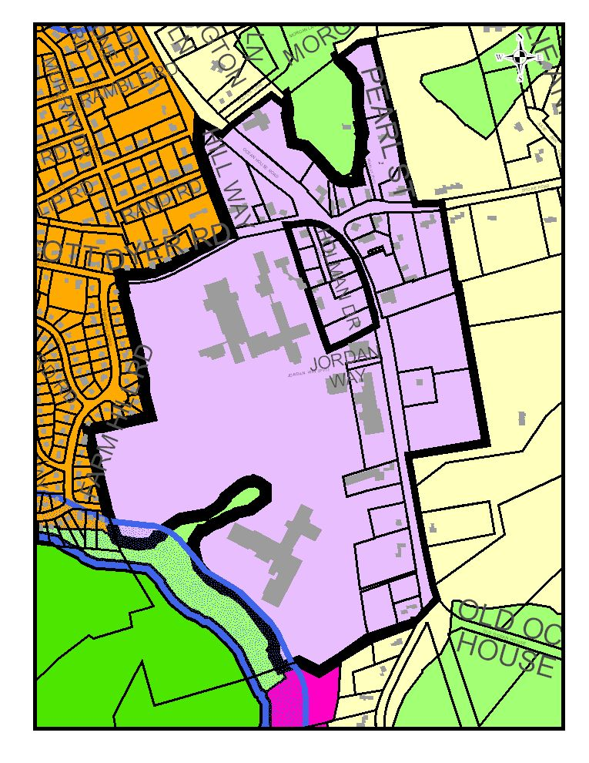**Appendix C**

**Evolution of the Town Center from 1993 to 2014**

The Cape Elizabeth Town Council adopted a Town Center Plan in 1993. The plan was prepared by a committee representing the Town Council, Planning Board, School Board and the Main Street 90 committee, as well as a town center business owner, a resident adjacent to the town center and members of the public.

When the Town Center Plan was adopted, the area of the town center was zoned predominantly Business A (BA) with the school campus, the Methodist Church and other “edges” located in the Residence A (RA) and the Residence C (RC) zoning districts. A major recommendation in the Town Center Plan was to create a new zone recognizing this area as the commercial/municipal/cultural hub. In 1995, the Town Council adopted the Town Center (TC) Zoning District and revised the Official Zoning Map to create the Town Center Zone.

The TC zone included several innovations, such as building and site design standards, sidewalk construction obligations on private property owners, maximum setbacks that require construction near the street and a prohibition of parking within the front yard setback. Taken as a whole, the Town Center Plan and the TC zone established an identity for the area now commonly referred to as the “Town Center.”

Cape Elizabeth is a suburban community that prizes its very modest growth, open spaces and rural character. Nevertheless, the town center has experienced changes since the first plan was adopted in 1993. Below are highlights of how the town center has evolved to the present.

**Town Center Highlights 1993-present**

•1993 adoption of Town Center Master Plan

•1994 Cumberland Farms adds canopy

•1994 Pond Cove/Middle School project

•1995 adoption of Town Center District Zoning

•1996 On Our Planet Day School moves into Shopping Center

•1997 Reconstructed sidewalks/lights from Farm Hill Rd to Jordan Way

•1999 Community Pool renovation

•1999 Scout House project

•1999 Public Works Department moves out of Town Center

•1999 Town Center Height Amendment rejected

•2000 New Police Station/Town Center Fire Station renovation

•2001 New Community Center

•2002 Romeo’s Pizza shopping center

•2002 Ocean House Child Development Center - Methodist Church

•2003 Sold Town land at 316 Ocean House Rd

•2004 Cape Elizabeth Family Medicine addition -Shore Rd

•2004 Johnson Scout House site plan

•2004 Pond Cove Addition/High School renovation

•2006 High School driveway traffic light installed

•2006 High School Hannaford Field

•2006 CELT new building

•2007 Jonesy’s garage bays removed

•2009 Town Center Amendments to increase multifamily density

•2009 Hannaford Field Concession stand

•2009 Intersection improvements rejected/pedestrian improvements installed

•2010 Portland Dry Cleaners - Shopping Center

•2010 Local Buzz opens – Shopping Center

•2011 Cape Family Medicine storage building

•2012 Shopping Center facade renovation

•2012 Town Hall landscaping

•2012 Shore Road Path connection to Town Center

•2012 C’s gourmet market approved

•2013 Well Heart Yoga opens - Shopping Center

•2013 L.P Murray and Sons renovation**Appendix D**

**Public Participation Process**

1. Transparency. All meetings, schedules, minutes, and other documents shall be available to the public for review.

2. Multi-level participation. Multiple approaches to engaging the public have been employed to maximize public involvement.

•The committee posted all agendas and minutes of meetings, the meeting schedule of the committee, and other documents and plans produced by the committee on the website.

•Time was set aside at each meeting for Public Comment.

•The committee used first class mailed notices to notify Town Center property owners and businesses and adjacent neighborhoods of the public forum.

•A Press release was issued to local newspapers focusing on the public forum and public opinion survey.

•A public forum was held on October 17, 2013. The minutes of the forum follow.

•The committee provided a status report to the Town Council in December, 2013.

•In addition, the committee distributed a public opinion survey. A compilation of the results follows.

**Town Center Plan Committee**

**Public Forum Minutes**

October 17, 2013

Town Center Plan Committee members: Stephanie Carver, Chair, Peter Curry, Skip Murray, Steve Parkhurst, Lee Rutty, Mary Townsend, Jamie Wagner

Staff: Maureen O’Meara, Town Planner

Mrs. Carver opened the public forum. Each committee member introduced him/herself. Mrs. Carver reviewed the committee charge from the Town Council and the draft vision statement for the Town Center. She explained that a survey would also be circulated and the committee agreed to also post the survey on the town website.

Ms. O’Meara reviewed the area of the town center and a brief overview of the town center zoning. She also presented a visual preference survey where attendees viewed pictures from other town centers and ranked them on cards distributed by committee members.

Mrs. Carver opened the meeting to public comment.

Laura Ker, 312 Ocean House Rd - She would like a slower speed on Route 77.

Suzanne McGinn, 1180 Shore Rd - The current town center is sufficient. The 1995 plan had 37 recommendations and one Town Councilor said about 60% of the recommendations had been implemented. The remainder should be the focus. None of the 37 recommendations say to increase the town center zone. The 2005 Critical Insights survey shows support for protecting rural character and improving the town center is second to last. There is congestion at the Route 77/Shore Rd intersection and it is the most dangerous intersection in town but the traffic light went in at the school intersection. The town didn’t want the Route 77/Shore Rd intersection light. The 2007 Comprehensive Plan does not recommend a change to the town center zone. If data is out of date, ask the Town Council to conduct the same survey using the exact same language. I like sidewalks and support more bikes, including by the school campus.

Imad Khalidi, 19 Pilot Point Rd - He is trying to join the Town Council and learn from tonight’s meeting. What is wrong with the town center? What is the position of the committee members? Maybe there should be buses for kids and for mothers. The town center is already vibrant. He then asked each committee member to state their position on the town center. Each committee member made a statement.

Skip Murray, committee member - He said that the town center is stale. It needs more pedestrians and more creative thinking between Buzz 1 and Buzz 2. He wants more places for more people to be able to gather as a community.

Lee Rutty, committee member - We’re not here to make changes. We are here because the Town Council asked us to look at the current plan. I don’t have an ax to grind. I like Cape Elizabeth and the town center, but I am not sure it should stay exactly the way it is.

Mary Townsend, committee member - She is interested in the school campus and safe connections for pedestrians. As a property owner, she is content with the town center and would like more green space, like a town green.

Steve Parkhurst, committee member - His expectation tonight is to listen, not to give my opinion. I want to find out what the townspeople want.

Mrs. Carver, committee member - She agrees with Mr. Parkhurst that tonight’s purpose is to hear from the public. She agrees that it would be nice to have community space but has no preconceived opinions. The town center will change whether we say yes or no due to the typical transfer of buildings, such as the bank leaving. It makes sense to re-examine and she wants to hear from others.

Peter Curry, committee member - The town center exists. Is it all that it could be? He would like to hear what people want.

Jamie Wagner, committee member - He almost didn’t move here because there is little in the town center. He had to open a coffee shop to have some place to meet in the town center and he has a great landlord. The town center is a little bit ugly and could be more visually appealing. He does not want to go to Portland. He has no interest in expanding the physical size of the town center, but would like more commercial activities such as shops, restaurant. With the empty lot, Skip’s lot, town property, Key Bank property, there is some way to be vibrant.

Terry Ann Scriven, 18 Old Ocean House Rd - She is a physician in the town center and agrees there are lots of opportunity for development within the town center. Do not expand the zone. We should have careful development in existing town center areas. She would like to look at the speed limit as she walks her kids across Route 77 to school and there is speeding through town. It would be good to look at sidewalks through the full extent of the town center.

Mark Kiefner, 5 Julie Ann Lane - He was attracted to the rural Cape atmosphere and values the proximity to the ocean, farms, ponds and trails. He has lived in bigger cities. He supports walkability, bikeability, and professional consultation on appearance. The current town center is unattractive and you should make it more attractive. He is opposed to changing the town center boundaries or higher density housing close to town center, which will increase traffic and decrease walkability/bikeability. Thank you for this effort.

Gerry Murray, town center resident from 0-73 years - He was on the previous town center committee. A lot has been done and he agrees the speed limit should be reduced because someone will get hurt. He does not see any consideration for elderly housing in town center. There are sidewalks here and we have land waiting for more residential to move into the existing town center area. My wife won’t move out and wants to walk to the bank, hair dresser, etc...

Frances Haywood, 1220 Shore Rd - She questions the status of the lot next to [north of] town hall.

Ms. O’Meara responded that the lot is privately owned. A site plan for a 3-story mixed use commercial/apartments was approved. That approval has expired, however, the zoning has not changed much since the approval and the plan was well received at the time, so it is likely that plan could be reapproved. The town’s approach has been reactive, where we put the zoning in place and wait for property owners to move forward. In other communities, a more proactive approach is taken and the town could consider a more active role partnering with property owners, and folks could comment on that.

Woman, Broad Cove Rd - She suggested encouraging the lot to be developed by raising taxes on it to its full potential value.

Craig Cooper, business owner, 30 year resident - He served on the FOSP committee and it is a thankless task. He doesn’t think we need to be concerned with changing from rural because the town is already small. Some restrictions in the town center make it impossible/expensive to develop the existing lot next door. It is ok to slow down the speed, but the main focus in the 1960’s strip mall, which is not very attractive. We need to attract more business, people. The town is not very business friendly; we lost two businesses to get the current community center building. He is ok with the high school driveway light. The Route 77/Shore Rd intersection is not as busy as intersections in other towns. We should encourage business people. He supports some architectural review and some open space. This side of Route 77 [east side] is pretty dead. With no new bank, it will be another empty lot. With some new business, it won’t be the maine mall, just some more people here and then we can improve the walkways.

Mr. Wagner asked Mr. Cooper to send an email with specific restrictions he would recommend changing. Mr. Cooper responded that the sidewalks and trees are too costly.

Sara Lennon, 54 Cranbrook Dr - She lived in Lincoln, Massachusetts. Unlike Weston, Lexington, the town decided to stay rural village. They voted money to make the shopping center pretty with parking in back. The town is gorgeous with preserved beauty and property values are high. Cape Elizabeth is like that. Every town around us made the town vibrant, but people don’t want Falmouth, Scarborough. We should have a town green, sidewalks, new building for a cafe but not for housing. We should embrace what we are. She also commented on the process. If the town council had to vote on this, all but 2 of the town center committee members would have to recuse themselves because of a public conflict. The Appointments Committee should not have selected persons with vested interests in the town center, including a real estate agent, business owners, town center resident, planner. You have a strong bias. Do you want a vibrant town center because you will make money? She does not want to be insulting.

Mrs. Carver said she appreciates that we should be careful about personal interests, but anyone with kids in the school or an elderly parent should also be interested in the town center.

Byron Castro, 188 Fowler Rd - The hard facts are this is a small town and there is a very low traffic count, with little traffic except for 2 times a day. Any major change needs to consider the traffic volume. He agrees we should have more business, but the big picture is that you would have to spend 1 million to build a building and you have to sell a lot of cups of coffee to pay for that. We need more than townspeople. We are a dead end and need something special to draw people. We can have small businesses, grow the tax base, but if we get too big, will also need to look at traffic. This is a good discussion.

Janel Voelker, 251 Ocean House Rd - She lives and runs a business in the town center. She represents Coastal Wellness and the Cape Business Alliance (CBA). She walks her son across the street from the Methodist Church and would like a slower speed on Route 77. She moved here 7 years ago and can drive to other communities for needs. As a business owner, this is a “drive-to” community. She opened her business expecting cape residents, but people are driving here from other communities to her business. She supports beautifying the town center and filling the empty spaces. The CBA has 25 business members and she encourages people to support Cape businesses. She loves the town hall look, the schools and library and wants to keep the New England feel.

Paul Seidman - He wants to lower the speed limit. Don’t add congestion and no high density housing. He rides his bike on Shore Rd and likes the pastoral land only a few hundred feet from the town center. No other coastal town has that and it is a high priority for him. He moved here precisely for its rural character and can go to the other end of Shore Rd for other things. Its uniqueness is what draws people here.

Amy Lombardo, 11 Leighton Farms Rd - She grew up here and likes the small town, but it can use some beautification. There is no place to gather, protest, have a coffee. She and a friend used to sit on a bench in the town center when she was a teenager. There is no bench now and she supports a town green. She would like a community board for announcements, sidewalks, bike racks, holiday tree.

Jon Donnelly, 5 Pearl Street - He appreciates the work of the committee and the meeting. The meeting minutes suggest that an agenda has been moved forward and he hopes we are heard. We don’t want condo complexes and we don’t want second story housing over commercial. We want a village green, pretty, simple. There are ways to partner to make a village green. His vision is that the Key Bank building is torn down and a grassy park is created with the Joan Benoit statue moved there, with a town sign. There could be a 3-piece band on Saturday night.

Bill Proom with Heidi, 11 Oakhurst Rd - We are new residents who moved from New Hampshire. Falmouth was unsatisfying. We support beautification, walkways, bikeways, safe route to school. It is a far cry from the town center to Route 1. Is 2-story building enough or 1/4 mile of new land. What is the end game? The town center, within its confines, done appropriately, will be embraced. The notion of expanding the town center zone with high density housing is not ok.

Frances Haywood, 1221 Shore Rd - There is a lot of open space in the center of town. I am inclined to approach the property owner, repurchase it as it is perfect for open space. Fort Williams is our town park. It would be nice to have a green in town with benches, guitar players, coffee. Maybe there could be a charitable sale of property for not much money. We should not expand the area of the town center. Why is Pearl Street in the town center when it is residential houses? Time to clean that up.

Hulda Khalidi, 19 Pilot Point Rd - It is great to keep the public apprised. In a small town it is too easy for rumors to spread. The horse farm is not for sale. People are disallusioned.

Imad Khalidi, 19 Pilot Point Rd - He tried to negotiate with Key Bank. There is a rumor that TD Bank is trying to negotiate to take over the bank. It should be public. It is an important part of town. The Town should tell of their negotiations between the town and TD Bank. Sorry Key Bank. Who is taking over? If it is the town, I want to know as I am a taxpayer.

Dick Gilbane, 226 Bowery Beach Rd - I live on property where we moved a barn in 1987. I consider taking the Haywood property and replacing it with development horrific.

Mrs. Carver stated that, as a group, that is not a recommendation this committee should make. We should move on.

Mr. Gilbane said he is glad the library was voted down. The design was heavy. The beauty of the town hall was lost on the library.

Steve Mohr, registered Landscape Architect, with friend Peter Haffenreffer - He has worked with Peter Haffenreffer for 30 years and Peter owns 4 acres next door [south of town hall]. The draft vision and town ordinance is positive because the vision is implemented by the zoning. The ordinance self-sorts potential development to meet the standards and intent of the committee. He suggests that the town follow through with some fine-tuning. The ordinance keeps down development scale and emphasizes design. If there is political will on open space, you might refine the zoning so that you can get the green space and give something back on existing land, rather than a town purchase. Specifically, on the two 4-acre lots south of town hall, there are RP2 wetlands not deemed significant by DEP. They are an impediment to development on those lots. Please look at the RP2 language in the commercial zone and perhaps adjust to allow development in the town center.

Mr. Wagner asked to clarify land in question and Mr. Mohr described the 4 acre parcel, the owner’s interest in developing the parcel, and the wetland obstacle.

Craig Cooper, 150 Ocean House Rd - He referred to the survey being distributed and noted that the meeting attendees is a small sample and it should be put on the internet.

Mrs. Carver noted that and the committee agreed to post it on the town website.

Nancy Bogg, 5 Julie Ann Lane - What is the purpose of the survey?

Mrs. Carver said it will be used to inform the committee.

Mrs. Bogg asked about the deadline?

Mr. Rutty said the committee will look at them at the next meeting. He noted that many people who attended tonight did not speak and this survey is another way for people to provide comments.

Mrs. Carver thanked everyone for coming and invited them to attend the committee meetings, which are open to the public. Agendas are posted on the town website.

The forum ended at 8:30 p.m.

**Town Center Questionnaire Summary Report**

The Town Center Plan Committee prepared a questionnaire to collect public comment about the Town Center. The questionnaire was handed out at the public forum, when over 50 responses were returned. The questionnaire was also made available after the forum online and a total of 82 responses were submitted to the committee. The questionnaire included 15 questions and additional written comments were solicited and received. A summary report of all the questionnaire responses and comments follows.

Questionnaire responses (82)

**Below is the proposed vision statement for Town Center Planning Committee:**

*To create an identifiable, vibrant downtown that includes mixed retail uses for residents and visitors, a safe and inviting pedestrian and bicycle environment, a common meeting place, visual vitality, and linkages to the town’s open space and nearby residential neighborhoods.*

**Does this reflect your vision for Cape Elizabeth’s Town Center? (Why or why not?)**

1. No. no emphasis on business development. I can go elsewhere for that.

2. Yes

3. Somewhat - as long as the town center physical space does not increase.

4. No. keep it rural.

5. Yes. within reason. Using existing empty space; no rezoning; no need to enlarge town center.

6. To also include open space, trees, benches

7. This is a good vision.

8. Yes, should be people-friendly, rural

9. Yes. open space, pedestrians, gatherings, no housing or expansion of town center.

10. Yes.

11. Yes.

12. Yes.

13. Yes, I like “vibrant” and open space

14. Yes, keeping open space in mind

15. Yes.

16. Yes, looking forward to a quaint charming downtown center.

17. Yes.

18. Yes.

19. I think elderly housing would be a nice addition to the center.

20. Yes.

21. Yes.

22. Yes.

23. Yes.

24. Yes, I think that is a well rounded statement that captures what our town is... inviting, vital, communal, safe.

25. Yes, except I think mixed retail is the lowest priority of the goals mentioned.

26. This does not reflect my vision, while it is important to have safe walking environment with sidewalks. I do not support changing the quaint feel of our town center nor do I think we need to change the TC zone. If anything, make it smaller.

27. Yes.

28. Yes.

29. Yes, a good balance of needs.

30. Yes in large part. We have the beginnings of same and people like to come to town to do much of their business without having to cross the bridge! I worry now, though, that we are losing “clean” business like Key Bank and Freshies, both of which were heavily used by Cape residents. We need to attract more of these.

31. Basically yes.

32. Yes it does, but I would change the word “downtown” (which might sound scary to some) to “town center”

33. A safe pedestrian and bicycle environment, okay. Linkages to town’s open space, perhaps. The rest are nebulous buzzwords too open to interpretation by those with a personal agenda.

34. If “common meeting place” means building a public bldg (new library), I don’t think that is needed. “Downtown” sounds like a much bigger business area than we have now. A few more businesses would be fine, eg. In empty spots such as former Jonesy’s but I don’t thin greatly expanded “downtown” is desirable. Prefer some green space. Current bus may be what population can currently support. Mixed retail, as well as restaurant, bakery, care type uses, and professional office space are good uses. Pedestrian and bike friendly is important but I am not in favor of an expensive rearrangement of streets, creation of a town common, e.g. for sake of ambiance.

35. Yes; and the previous plan look fine, still.

36. Yes.

37. Yes. I feel like we live in a community where we would all take advantage of this. Plus keep money coming into the town. I would rather shop/eat in Cape than drive to Portland as often as I do.

38. I do like the idea of a small town/sea side shopping village fee.

39. Sure.

40. No, the cost to achieve this vision would spike property taxes for years and is ultimately unachievable. Gradually going in that direction by favoring the vision during planning decisions, at zero cost to the tax payer is preferred.

41. Yes.

42. The town center should be pleasing to the eye as people drive through. It does, however, need businesses to survive, and to keep the residents in town.

43. No, I have no need for a “vibrant downtown”.

44. Do not believe we need a “Town Center” as such.

45. No. I think it is already identifiable; the word “vibrant” disturb me. It needs no more retail uses, and the only safety issue is the narrowness of the parking space for backing out from the CVS pharmacy. You’ll have to define “visual vitality”.

46. Everything looks good, but I would like to see some mention of the environment. It should be well landscaped and attractive, with flowers and shrubs.

47. Yes, I find myself going past the town center for things that a town of 9,000 people should have. We have a unique chance to create a place that connects all the good things about Cape – open space, people, and give residents an opportunity to create and take part on local business.

48. Yes

49. Not sure we need more meeting space. In my experience the community service building is under utilized.

50. Yes, we moved here from Longmeadow, Ma. which fulfilled the above vision statement and loved the town for that reason. It had a small, vibrant and visually appealing town center with retail but maintained a quaint New England town feeling. The town had sidewalks throughout for easy pedestrian and bicycle access. The town also had ample green space. The combo of the “right retail” tailored for resident interests, sidewalks and green space makes a town accessible and appealing for all ages and uses without making it too “busy” or losing the “small” feel.

51. Not entirely. I am less concerned with retail space than with the other aspects.

52. Yes, very much so.

53. No, I don’t think there is a need for this. There are a few aspects that could be improved, such as the empty lot next to the Town Hall, but otherwise, I don’t think the Town Center needs any major re-dos.

54. Basically, yes, but there isn’t much hope for more businesses.

55. “Downtown” is not the descriptor I would use. Town Center is more accurate. We are not a city that has a “downtown”. The town center should be appealing, have mixed use and have parking available. Not sure what is meant by “linkages to.. open space… and… neighborhoods”. Does this reflect my vision? 50% only.

56. Yes it does. It encapsulates what I consider a small town center and on par with some of the other coastal towns I enjoy visiting (Kennebunkport, Booth Bay, York, etc.) Obviously we are smaller scale and not on the water but with the right blend of development we can keep the small town feel but also increase needed revenue.

57. Yes. The Town is sorely lacking an identifiable downtown.

58. No. I don’t see a vibrant downtown in CE because of the history and nature of the town. There is not sufficient land available to create more business uses, plus there are several current vacancies. It seems doubtful that people will change their habits when all services are available and convenient elsewhere.

59. Yes.

60. Yes, it covers most interests, but needs some fresh life.

61. I do not agree with the word “create”. I believe that towns spring organically from the need for a focused commercial grouping of buildings. Government does not create towns, commerce does. The “create” a town center (“mixed retail uses”) is a much different issue than modifying existing structures/road/landscaping to be more conducive to “common meeting places” and “linkages to town’s open spaces”. This mission statement is much too broad.

62. Yes. Although we already have some retail and I wouldn’t want too much development.

63. No. It implies a change is needed and as far as I’m concerned it’s fine. Just focus on getting that empty parking lot next to Town Hall into something less ugly.

64. No, it does not. The unique beauty of Cape Elizabeth lies in its simplicity. The convenience to the commercial sites in S. Portland and Portland makes any development within Cape Elizabeth totally unnecessary.

65. No. I think there should be rental/condo residences as well I would like to see mixed use.

66. No. I never looked to CE to be a big (vibrant) retail center. If CE is over built costs potentially (usually) go up, traffic increases and the quality of rural small, quiet town ceases.

67. This is workable as a start.

68. This represents a good vision – a mixture of uses to meet the needs/desires of both residents and visitors.

69. Yes. A town center keeps Cape Elizabeth’s money in Cape Elizabeth. We can compete with Portland on charm, retail, and restaurants.

70. Yes. I prefer a town proper to a suburb.

71. I don’t really think that “vibrant” is the quality that we should be striving for. I like the idea of user-friendly and open for safe and easy pedestrian use. The rural feel of CE is one of its strongest attractions and greater development generally runs counter to that sense. There are commercial centers, nearby South Portland, where most needs can be met with minimum inconvenience.

72. Yes, this is a good plan to promote more of a town feel as well as more vibrancy and substance to Cape Elizabeth. We need places that will attract people to come here and enjoy what we have and patron our businesses for economic growth.

73. Mostly – I question “vibrancy”. I don’t see or want too many businesses in town as that would change the flavor of CE.

74. No. While these things sound nice at 1st glance, the town center of Cape Elizabeth is fine as it is. I feel it is the heart of Cape Elizabeth & that there is no reason to change it. South Portland & Portland are close enough to take advantage of those type of things. Why would we want to increase our traffic like other towns & no longer be considered a rural town? I have no need for additional stores & I was upset when Jonesy’s closed & Freshies opened.

75. No, it does not. Every effort to develop an artificial downtown that looks like the photos in the PPT presentation should be resisted. Let’s keep CE “identifiable” by keeping it unique. Once it is “developed” it can never be returned to its wonderful present state. We’ve all seen the enduring impacts of myopic goals of improvement. Let’s reject it.

76. I think the word “vibrant” may be too strong. Would be nice to have a more welcoming/defined town center but should be keeping in town’s rural character.

77. I would not list retail at the top of the list.

78. Yes, this definitely reflects my vision. It includes of all the necessary elements for a much-needed Town Center.

**What do you like about the current Town Center? (What should stay the same?)**

1. Lack of build-up of business and development. proximity to rural and pastoral spaces. small town feel.

2. It is very dated! We need to move businesses in town.

3. The simple small nature.

4. Sidewalks, trees, green, sleepy, bedroom community

5. Keeping it small, walkable.

6. Rural, low key , walkability for groceries, pharmacy, coffee, food, etc.., great businesses, community center

7. There are basic amenities: IGA, bank, cleaners, doctor, etc

8. Small rural environment, small businesses and shops, cafes

9. Smallness of it, access. Needs upgrading.

10. Like it; but need more development.

11. Compact, reasonable array of basic services.

12. Town Hall, library, front of the police station, trees and lights on Scott Dyer in front of the middle school.

13. The New England Charm - the look of Town Hall, school and library

14. I like the businesses - yoga studio is great.

15. Small area.

16. Small, quaint.

17. Size is fine, visually inadequate.

18. Size works.

19. Location is fine, size fine.

20. Schools, police, library and some services all in close proximity.

21. Rural

22. I like the fact that our town center is “low key”, contains locally owned businesses, is visually pleasant, and is easy to navigate on foot, bicycle, or car.

23. Location of public and municipal services, food store, drug store, Local Buzz, CELT, School complex, gas station/convenience store.

24. I like the fact that we have few businesses that are set back from the road. All parking is off Rt 77; sidewalks are important, NO FURTHER development beyond existing vacant lots.

25. Reflects the size and tastes of the community.

26. Honestly I do not know where the town center is! Is it by J. Benoit’s statue, at the Town Hall, at the I.G.A.?

27. Some shops/commercial establishments. Would be nice to have a bank, but may not be possible. Stay with no traffic light.

28. I like that I can go to the Pond Cove Shopping Center, use the post office at IGA, visit the library, do business at Town Hall, get gas.. all within less than ½ mile of each other. But, we also need another good restaurant.

29. T Hall

30. I like that the schools and library are in the middle of town.

31. It’s fine. Leave it the way it is.

32. It is fine. Compact area with a number of businesses and there seem to be buildings available should new businesses care to open. Having a grocery store and pharmacy are convenient.

33. Unifying character.

34. Everything is pretty close together – easy to walk from Town Hall to library to schools to café/shops.

35. Not much.

36. There is not much to like about the current Town Center. Half of the buildings are municipal buildings which we do not utilize on a daily basis. The retail spaces are limited. If people in town were disappointed to lose Freshies, that says something!

37. It is clean, tidy and practical. It is not “picture-postcard” but that is not an issue for us.

38. Compactness of schools, Library, Town Hall, etc.

39. The Town Hall is pleasing. The small street lights and trees along Ocean House Road are very attractive.

40. Very little. Open, ugly spaces.

41. Like the retail mix as is, with the exception that a nice clean restaurant would be appealing and empty buildings do not convey ?????? (46)

42. It’s fine.

43. Not that congested. Low key.

44. Services are central – town hall, schools, library, small shopping center.

45. We like that it’s a starting point with some retail – IGA, Local Buzz

46. Town Hall, it is beautiful. Wish the other buildings had the same architectural integrity.

47. I like the quaint feel of the town hall, the police and fire stations. I like the way all the schools (high, middle, elementary) are grouped together. I like having a store to get a few grocery supplies on short notice, a pharmacy and a gas station for convenience. Having a coffee shop is great!

48. The Town Hall itself is quaint, functional, well cared for wonderful building. Vacant lot an eyesore. Celt building a lovely addition.

49. Nice, small-town feel. Love the library and small businesses (chiropractor/acupuncture, family doctor, real estate, consignment clothing store) Not a fan of the strip mall but like the mix of businesses there. Love the Town Hall and CELT office, also schools/community services. Police station looks great.

50. Basically, it is fine the way it is. Cape Elizabeth is not a town that is a “bedroom” suburban community, and the Center doesn’t need to be “prettified,” or enlarged in ways that will increase traffic congestion and overcrowding.

51. I want to be able to drive thru the Town Center on Route 77 as I do today – no onside parking or additional traffic lights.

52. I honestly don’t feel there is a town center to like today. The Town Hall should definitely stay and the “center” should be build around that structure. There is no connection and too many gaps along Rt 77, but those are opportunities to build. The IGA plaza is also a good landmark to build around.

53. I appreciate the “idea” of retail space but think it’s been poorly executed. The grocery store is helpful.

54. I think it is fine the way it is. Efforts should be made to fill existing vacancies before embarking on any new scheme. We do not need a Town Green or more park space. We already have a beautiful park at Fort Williams with plenty of Green Space. We don’t need another band stand, lets fix the one at the park.

55. IGA

56. Convenience, local feel.

57. Its simplicity, country like feel, without traffic lights or commercial traffic. Its safer now that if the town tries to instigate further traffic from retail shops, etc. I would leave it as is since it is apparent the retail attempts have struggled in the past, they come and go which indicates that CE is not a “destination” to shop. Sprucing up the IGA complex with a new facial would help. Do we really need another “common meeting place”? What does that mean considering the Library, Community Center, etc.

58. I like the Town Hall (traditional style), the fact that there are houses/residences interspersed with public use establishments (library, town office, etc.) and that every available space is not developed.

59. I like that it’s small, quaint, and has wooded/wild lots of space.

60. It has the basics that any town needs. Gas, Bank, Grocery, Dry Cleaners and Coffee shop are my regular stops.

61. I like the IGA and the CVS. There is not much else I like. I would like to see a real restaurant, baker, ice cream. A gift shop would be really nice.

62. Everything. More or less everything.

63. I don’t give it much thought. I just use it. It’s a series of businesses and a strip mall and schools.

64. Easy to park to shop, easy access to Town Hall, Fire and Police. Although no “village green”, the Land Trust property gives a nice “rural” feel to the town center.

65. Town Hall façade; library offerings (ideally expanded to provide cultural programs and community meeting space).

66. Not much except a couple of older buildings such as Town Hall.

67. Gas station, IGA, The Local Buzz, Post Office, CVS. The rest of the businesses don’t seem to add anything to a town center or draw in people from other places. Obviously the library & Community Center are essential but don’t seem to be truly in the town center. What are IS the town center?

68. The “quiet” atmosphere should stay the same.

69. I love it as it is. Why in the world do we need more? I am always proud as I drive through the town or go to the town office for something. I have no need or desire to see anything else there. Ft. Williams gets enough people – they can drive through the town & see how wonderful it is if they want to. I don’t want to make anything bigger or “better”. No need for more services/people.

70. I like that it hasn’t substantially changed in my 56 years. THAT is the true treasure of CE that must be protected against misguided notions that it is somehow lacking because we don’t have a Starbucks, health club, or town common. Let’s not forget that the town didn’t generate enough sales to keep a hardware store or garden center in business.

71. Town Hall, not much else.

72. The Town Hall, library, schools, police, ambulance and fire and the Community center are the core town services for residents and should receive top priority. I like the variety of retail options available.

73. I’m not sure I would classify the current Town Center as a “Town Center”. The strip of businesses are a good mix, residents can benefit locally by grocery shopping, getting a cup of coffee, Rxs, dry-cleaning, yoga, tutoring.

**What would you like to change about the current Town Center? (What would you like to see added? Taken away?)**

1. Lower the speed limit through town center.

2. Slow down; make it easier for people to bring a small business into town.

3. Leave it same size - but increase green space - “beautify” what exists.

4. Finish the sidewalks; replace the dead trees, town center green.

5. Expanded sidewalks; town $$ to improve beauty of town; open space - gathering space.

6. Parking in the back of retail, etc, trees, open space

7. The town needs to develop a form based zoning code to improve the attractiveness of the town, its walkability.

8. Would like to see more green space; get rid of strip mall look

9. Cosmetic changes to strip mall; flowers, hanging baskets, nothing too expensive, paint

10. Greens; more buildings; sidewalks.

11. Better appearance.

12. Better traffic flow, more pedestrian-friendly, get parking out of the way

13. The IGA, CVS building is ugly and parking is too tight. If more businesses move in we need to consider the parking needs.

14. Beautify shopping center and existing space; lower speed limit; green space.

15. Lower speed limit. More sidewalks, more green space.

16. More smaller businesses.

17. Beautification, town green, gathering spot, signage, sidewalks.

18. Speed limit is 35 in TC, decrease to 25. I support the development of the empty lots including apartment space.

19. I would like to see increased housing, a gym, more businesses, etc.

20. A small park would be nice, however, we had our chance when the murray shed , the lot next town hall to the town and they chose to sell it.

21. add town green and sidewalks, beautify 1960’s strip mall retail.

22. I would like a small outdoor space for people who work in the town center.

23. I would like to see a sidewalk from the high school to the end of Fowler Road. It sort of ends along 77. More local business would always be welcome. Fast food and big box stores should not be allowed.

24. See priority ranking below.

25. Grass the undeveloped lot next to Town Hall + in front of HS until it gets developed. No adding needed. Reduce speed. Add a rotary @ Rt 77/Shore Rd to reduce speed, have town buy Cumberland farm which is now for sale and use land for rotary & green space.

26. A bank (if no one replaces Key Bank).

27. My hope, for a while, is that the Town Center be located next to the Town Hall and that it provide encompass a gathering place for “Capers”.

28. More sidewalks. More town center located residential housing, Make the IGA strip look better.

29. I would like to see the long-articulated vision for the Thomas Memorial Library realized soon but do not move it any place else as it belongs in the Town Center as a place for all members of the community to access information in all formats and as a gathering place for programs and events.

30. I would like to see several current buildings demolished and the whole area more open and interesting.

31. Add a few retail businesses of small scale and places for business-people such as business incubators.

32. The little strip mall is kind of ugly. If it were up to me I would remove it and plant trees.

33. It is fine. The Town Center Committee strikes me to some extent as a solution looking for a problem. The center is build around a state route without a village of clustered housing. It doesn’t seem feasible or desirable to me to try to convert it into a village.

34. Sidewalks on both sides of tree-lined streets w/lighting, street parking, green on Rt 77, extend all to triangle, make Rt. 77 a round about at Shore Rd.

35. I’d like to see a fountain or some kind of focal point.

36. The look. Add more shops, restaurants, common area. Make it walkable.

37. I am in favor of adding commercial businesses to the Town Center. More commercial businesses to me mean more tax revenue. I would like to think this would mean less burden on property/home owners and our ever constantly increasing property taxes.

38. Green/open space if there are retailers that would lend itself to using the open space (bakery/food so people could picnic)

39. The two vacant lots should be developed.

40. I wish there was a town common rather than the main road structure, but I don’t see how that can happen.

41. The shopping center should be totally be revamped. The building is outdated and very unsightly, and there is not nearly enough parking to accommodate the businesses. We have just lost our only bank and one of the two variety stores. They should be replaced soon, so that the business will not leave the town.

42. If anything, a means to receive cell phones in our area. Of course, nobody else cares (those who have reception) don’t want anything in their back yard.

43. Like the thought of having the vacant lot next to Town Hall converted for open space, plantings, perhaps a few benches and a band stand.

44. The essence of the “center” should be a green open space in the undeveloped lot next to the Town Hall.

45. More green, perhaps a water feature. More trees.

46. More and varied business spaces, arts spaces, places to meet others etc.

47. We would like to see more retail/restaurants & a common gathering space I.E. green.

48. Town center will not be inviting until the 77 – Shore intersection is redesigned. It was short-sighted to put the light at the high school. Any more traffic density will be a problem.

49. I would like to see a little more commercial development and a town green space. For commercial development, I am thinking of small homegrown businesses that serve as gathering spots similar to the local buzz (for examples: a hip breakfast/sandwich spot, bakery, dessert shop, gourmet store selling specialty products/cheeses, Maine made product store, clothing boutique.) More sidewalks and an open green space with a pavilion for community concerts and events would be nice too.

50. Would like a rotary at intersection of Shore & 77.

51. I wonder what we can do with the recently vacated gas station. Isn’t the bank for sale also? I would like to see more small businesses thriving there. Not sure what? Pizza place? Bakery (think Scratch-what a huge success!) Love the ideas below for the intersection using natural ways to slow traffic (median with plantings, etc.) No traffic light!!!

52. The empty lot beside the Town hall was once planned to have a building that was two stories with a coffee shop and perhaps one or two shops on the first floor, second floor was going to have one or two apartments. This seemed like a good idea.

53. That lot next to town hall is an eyesore. Rather than trying to put an office building or retail establishment, I would suggest a small park with some landscaping and a benches and perhaps a swing for the kids.

54. Not enough parking for the businesses at the IGA strip mall. The intersection at 77/Shore/Scott Dyer needs work. No traffic light needed. We do need traffic lines on the road at the intersection. There should be two lanes at the intersections for those turning on to Scott Dyer from 77.

55. I would like to see a “center” that stretches from Scott Dyer down upper part of Shore road and down to Fowler road on both sides of the road. The Town Hall should stay. To complete the “main st” would require moving rezoning some residences in order to build close to road. We need more retail stores and restaurants. I picture Kennebunkport.

56. Develop empty lot next to Town Hall. Improve pedestrian walk-ways. More retail shopping, dining. Less commercial office space.

57. Don’t spend any more tax dollars, or grants, on the Town Center except for essential. Current sidewalks are adequate, and we don’t need on street parking, or landscaped medians.

58. Bank.

59. Small garden area, seating something “seaside” to make parking area visually attractive.

60. Upgrade the exterior of the IGA complex to reflect a more “New England” architectural connotation with more singular identity to each shop. We need only one gas station. Reconfigure the parking lot layout for the Town Hall. Too few spaces along side the main building use the lot next to the left of the Town Hall.

61. It would be nice if the vacant lot next to the Town Hall could be purchased and turned into a green area, a small park with a gazebo, for instance. Also, it would be fun to have a bakery or small restaurant on the corner where Key Bank will be closing in December.

62. Nothing except that paved area next to Town Hall.

63. The open spaces that are not being used should be landscaped to look less “vacant”.

64. I would like to see a mixed use development in the lot next to Town Hall. Get it back on the tax rolls.

65. If the library needs to add more space they should get what they need because they provide valuable vibrant asset to CE community for all age levels.

66. Make it more pedestrian and bike friendly. I notice later items on this topic. Re hiring consultants (below), contact GrowSmart Maine, 415 Congress Street, Suite 204, Portland, ME 04101 207.699.4330 x 3

67. Disturbed by the number of closed businesses – doesn’t seem to be a vibrant center. The empty lot next to Town Hall has been an eyesore for a number of years. Other businesses try and fail.

68. More mixed-use retail (perhaps with housing above shops); safer pedestrian crossing; consistent, thoughtful New England architecture.

69. Change traffic flow: roundabout if possible; chicanes along a retail strip. Like a denser building pattern (maybe two story retail below & residential above).

70. The lot adjacent to Town Hall should probably be utilized, maybe for a band stand, in a park-like setting. The library should be upgraded, but in a way that is consistent with the rest of center, not too modern.

71. Add retail shops, eateries, and a “village/town” green. Move the small businesses who are using “prime” real estate & adding no value, places that could be housed in any office bldg. Don’t allow vacant land in town center ie: next to Town Hall. A cohesive aesthetic appeal to everything in that area. Add visitors’ center to include town history.

72. I would like the sidewalk on Rt 77 completed to Fowler Road.

73. Nothing.

74. Nothing added please, just slow down traffic through reduced speed limits and better police enforcement. I would like to see the charge of the TCPC changed to emphasize preservation of rural character and resistance to development, or, disband the group entirely. I honestly have to question the motives and hidden agenda behind this effort.

75. Reconfigure intersection & make a more identifiable town center but not a “vibrant downtown”.

76. I would like to see the Local Buzz restaurant expand or another restaurant with casual food open. I would like to see a village green with a gazebo and music played for us to enjoy, at a site with seating (benches and picnic tables).

77. I would like to see more mixed uses. Also another restaurant, and if financially feasible, a small hardware store. And – I do think we should provide some affordable housing or condos that would attract middle-class working families.

**The committee has discussed several approaches to looking at the Town Center district. Please share your thoughts about the following:**

**Research**

**Should the town hire an independent firm to conduct an assessment of the economic development potential for the Town Center of Cape Elizabeth? (The assessment could evaluate the economic viability of Town Center.)**

22 **Yes**

57 **No**

1. It would be nice to have options – from pros if we need the help

2. Design first, development consistent with design.

3. No. The market can best evaluate what is economically viable.

**Should the town hire a firm to conduct a statistically-valid survey to assess the desires of residents for future Town Center development/growth?**

32 **Yes**

44 **No**

1. We have a valid survey from 2005.

2. Yes – once options are presented.

3. If, as a result of this survey. The decision is to proceed.

4. Broaden this survey.

5. Why hire someone – put this on website for residents to fill out & submit electronically

6. We already know what citizens want through comprehensive plan.

7. This is a waste of tax payer’s money.

8. I trust our town leadership to conduct necessary surveys.

**Are there other studies/research you would like to see explored prior to moving forward with recommendations? Please elaborate.**

1. Re-offer the precise questionnaire from 2005

2. Not do economic development assessment until town resident survey using the same 2005 questions with Critical Insights. A design firm hired to draw up plans for an attractive town center ideal. Several designs.

3. How to zone, tax and promote developing of current vacant properties.

4. Landscaping recommendations

5. I think resident desires could be assessed through an exit poll on voting day.

6. Not sure on economic assessment, depends on cost.

7. I think we all have enough common sense to plan for our town center. There isn’t that much land left.

8. It seems to me that even if a survey says there are opportunities in our town for growth there still needs to be people to build the businesses. There is plenty of land available and at least one empty building; seems the opportunities are already present.

9. You could complete the EXACT same Critical Insight Survey of 2005 to answer the question we already know the answer to. We are turning our wheels & wasting volunteer’s time by prolonging the process of a town center when we already know the sentiments of our community.

10. Really not sure – if you receive a lot of citizen input, you may not need more research.

11. The cost of hiring someone to do a study should not be too high.

12. It would appear to me that the same firm would be able to do both of the above, and we would have the information and data we need to move ahead.

13. Can we find out what homeowners who abut the town center will accept/fight?

14. Get rid of the police dept, make their private gym open to the public, use the rest of the building for the new library and contract with the county for police services.

15. While I don’t want to spend money on a study, I don’t think the committee should really recommend major changes without being able to back it up with some examples of other similar towns that have done something similar and recognized significant benefits from doing so.

16. I think the town can figure this out without spending money on outside firms.

17. I would like to know the impact on my property taxes. I would expect that with an increase in commercial/retail businesses in the town that our taxes would not continue to increase at the rate they do annually.

18. I can’t think of any.

19. All the Town seems to do is hire out independent firms to study everything. Nothing seems to come from it except a bill from these companies.

20. I think the majority of the people have clearly expressed what they want. Yet, again, after being rejected, there is always another commission, who tries it again. If we can’t have a 6 mill. library, let’s see if we can get a 4 mill. One. Libraries are not about playgrounds, meeting places, etc. They are not even about books anymore. They are about function.

21. They to adhere to thoughts expressed in this survey and recent survey.

22. Is your vision statement a recommendation? Is it a “given” or can it retreat until verified in the next Comprehensive Plan?

23. A study of the overall look and impact.

24. I have worked with both Sustain Southern Maine and Growsmart Maine to host workshops where people vision what could be developed in a very specific way with co-operation of property owners. This might be helpful in terms of process to see what would be possible to accomplish.

25. Traffic, pedestrian, open space design.

26. No, I do not think we should spend our money on outside consultants. I think we can figure this out ourselves.

27. No. This has been studied and talked about for 2 decades. We should have viable businesses in the town. If zoning is a deterrent, than we should look at the zoning laws and consider change. Would a change harm the uniqueness of Cape Elizabeth?

28. We don’t need any more studies. Let’s stop trying to create fantasyland. It is fine the way it is. Let’s make sure our rules and regulations are business friendly enough so the existing properties can be support viable businesses that residents will support. Obviously, they didn’t use the banks enough to justify having branches here.

29. Too much data to share here but do consider commercial “sprawl” and retail for “retail” sake. CE is a bedroom community and in my estimation not a Town, Village or even Hamlet. Town Centers composed of people/buildings spring from communal need, and not the need to build a town center, it’s a different paradigm.

30. Use Comprehensive Plan.

31. I feel the studies are an unnecessary expense. As most residents would agree, Cape Elizabeth is an incredibly special place to live – As it is now.

32. Let the free market determine the uses.

33. No outsiders assessing. All this sounds expensive + benefits only a few in the sort + long term. Contractors, real estate agents, the DOT, business owners benefit more than individual homeowners.

34. What kinds of businesses/services would residents like to see in the town center beyond those already there? Would they be viable in Cape? Hardware stores and banks seem not to be able to make it.

35. Residents should be able to figure this out. If large outlays of money is required than this would/should go to a referendum.

36. I would suggest exploring a business association for Cape to promote development, growth & sustainability of businesses, retailers & organizations in the town. Please see a GREAT example: [www.oldeworthingtonbusinessassociation.com](http://www.oldeworthingtonbusinessassociation.com)

37. Get estimate of cost for sidewalk to Fowler Road.. Reach consensus on which design of 1993 Town Center Plan is/would be cheapest to recommend. Once an “approved” TC vision is made, plan accordingly for possible green space.

38. I’d be interested in any studies that reflect the residents’ opinion of the unintended negative consequences of a well meaning but misdirected Town Center Planning Committee. There must be K’s of cases available. Are our taxes paying salaries for people on this committee?

39. Some ballpark estimate on cost & what it would do to taxes.

40. This idea has been discussed enough in that it really does not require further economic impact studies and surveys. Also, the growing trend of families relocating look at things like a vibrant community, Main Street, etc.

**Housing**

**Should more multi-family housing be added to the Town Center? (Either as stand-alone condominiums and/or as part of a mixed use including retail spaces?)**

27 **Yes** (1 - mixed use only)

52 **No**

1. Too much road/traffic congestion already.

2. We have plenty of housing in Cape.

3. Sure if there are landowners who wish to develop apartments, there are probably lots of people who would be interested in affordable housing. I don’t think there is any good reason for encouraging high-end expensive places, but it shouldn’t be outlawed either.

4. At the developer’s cost.

5. I think the town center, other than the lot next to Town Hall, is busy enough.

6. Only if it includes retail space.

7. Both.

8. Yes, but only mixed use to create a denser core center.

9. Yes, helps to enable a dense town core.

10. Special consideration to senior housing – perhaps a senior housing condo unit building.

**Pedestrian and Traffic Safety and Accessibility**

**Should the town evaluate roads, sidewalks and pedestrian pathways to determine safety, connectivity, and adequacy in and around the town center?**

61 **Yes**

16 **No**

1. If you are looking to create work + expense for our town, we don’t “need” it.

2. This should be the first study.

3. Reduce speed limit to 25 mph.

**Should the town consider implementing traffic calming measures for pedestrians and cars in Town Center? (This could include techniques such as bump outs, installing a median with plantings, reducing the speed limit and adding on-street parking.)**

50 **Yes**

31 **No**

1. No on street parking. That is dangerous! Again, we don’t “need” these features. If you just reduce the speed limit.

2. Reducing speed limit through town center is okay. As a cyclist, I think on street parking would make riding more dangerous. The wide shoulder on Route 77 is very good for cycling safety and I would not like to see that compromised by bump outs etc that would narrow the shoulder. As a driver, I think a median could increase traffic congestion.

3. Median – sure, reducing to 30 not 35, no on-street parking.

4. Very important! Needs expert input.

5. Reducing the speed limit to 25MPH thru Town Center

6. Yes to installing a median with plantings, reducing the speed limit. No to on street parking.

7. Yes, roundabout + chicane

8. Could again request lower speed limit on Rt 77 in the TC. A bike path probably not possible as it may require widening of the road, but could help keep bicycles from riding in car lanes which I think is a growing problem.

**Should the Town consider adding a traffic light to Town Center at the 77/Shore/Scott Dyer intersection?**

30 **Yes**

46 **No**

1. Rotary if anything or move HS light to this intersection

2. This is an awkward intersection but in a way it is a “traffic calming” feature. You have to slow down and pay attention. I live off Shore Road and I don’t have a problem, but am not totally against a light. If Shore and Scott Dyer were aligned and there was a stop light and 4 cross walks, it would probably be a safer place for kids to cross when walking to school – except for people turning right on red without stopping.

3. I would prefer to not have a light but if there was increased traffic due to having a downtown/destination it might be necessary.

4. Consider – not a given. If pressure plated for shore + Scott Dyer, such that 77 is mostly green.

5. Already have a “caution light” reduce speed limit to 25 mph.

6. Yes, but we have been there done that!

7. Prefer roundabout option first.

**Should the town pursue extending the sidewalk network to improve connectivity to Town Center and to potentially increase foot and bicycle traffic. (For example, expanding sidewalk connections from neighborhoods near the town center, e.g. Wells Rd, Fowler Rd, etc.)**

61 **Yes**

20 **No**

1. If you “need” a project.

2. If doesn’t reduce the shoulder that is available for cycling. That would be less safe for those of us who ride fast enough that we are riding in the road with traffic rather than on a sidewalk.

3. Big yes!

4. Need to connect schools, library, Town Hall, police more like a campus.

5. Yes – Fowler, but Wells is too far away and would be too expensive.

**Green Space and Visual Attractiveness**

**Should the town establish an outdoor public gathering place, such as a Town Green, to promote visual identity and to establish a more aesthetically appealing Town Center?**

56 **Yes**

21 **No**

1. Not necessary, it is a luxury. But if you have to do something, than it would be ok, although there is no obvious spot.

2. A park is always nice, but I would not be for reducing the business space or parking in order to do this. And I am skeptical that it would really create the desired village feel. I do not really see myself hanging out there.

3. Yes perhaps next Town Hall.

4. No, we have more than enough green space in C.E. We need to have economically productive property in the town center.

5. The space next to the Town Hall (paved, near Key Bank) appears unused. Seems it might make a nice skate board park for the kids or community garden or small park for people and dogs.

6. No, unless modest in size.

**If yes, what activities would you like to see on the Town Green?**

1. rural gathering. nothing else.

2. Gazebo - park benches - amphitheatre

3. community gardens, park benches, flowering trees, kid-friendly furniture

4. gathering space, performance space, open green space

5. Picnic tables, playground

6. Farmers’ market; “art” in the town center; food carts in green spaces (same as Ft. Williams regulated)

7. Concerts, festivals, tree lighting, attractive sign for information

8. Concerts, community events

9. Benches, decorative trees, gardens, fountain

10. There’s more snow than grass.

11. Tree lighting, concerts, a festival

12. Concerts, public events, general public use for picnics, play with my daughter there

13. Heated for winter use, street musicians

14. I see Thomas Memorial Library as a current town green. As long as that doesn’t change I think we’re covered. Music, comedians, picnics, etc. are all great things that happen at the current town green (TML).

15. Skating rink, Christmas tree, concert area.

16. Town green, coffee shop, meeting place, celebration of holidays.

17. It would be nice to have a town green, but I don’t know where it would be. All the real estate in the town center is taken, I believe.

18. I would like to see the town Green be an extension of what is currently in place on Scott Dyer Road in front of the Library. In fact, with a new Library in the offing this could become a well-defined outdoor public gathering place as it is now sometimes used.

19. In appropriate weather, more people outside. There is presently no place outside for any activities.

20. Shakespeare performances like are sponsored by the library, band concerts.

21. Community band events, farmers market, etc.

22. Place to sit outdoors and talk with friends.

23. Christmas time events – tree lighting. Art fairs, etc.

24. I think it would simply be aesthetically appealing but could be used as a meeting spot, play area, picnic area.

25. Picnic tables, swing set (though I think there are sufficient playgrounds in CE.

26. Make it pleasant to look at – not like downtown Detroit.

27. Gambol - seriously, an open space with perhaps a central gazebo for focus of gatherings.

28. More effort and money put into landscaping and less on constructing buildings. By the way, the police building is downright ugly. Especially, compared to the town hall.

29. Art shows, farm market, music, starting line for running/biking events.

30. Music, fairs, tree lighting/holiday event

31. Low impact- just a nice spot to sit, chat, have a cup of coffee, keep it simple.

32. A small pavilion for community concerts and events. Fountains and gardens with benches are always enjoyable.

33. Veteran’s Day, kid’s festivities

34. Concerts, use by teams and organizations for sales/swaps of equipment. Could we set up a hose for car washes?

35. Relaxation; meet friends or strangers to chat.

36. We already have a “Town Green” at Thomas Memorial Library. We do not need anything along Rout 77 to hamper traffic. If we want a Town Green we should publicize the library’s space in front of that building. A second idea is to utilize the lot next to Town Hall as a public green. It has sat empty for years. Plant some grass and have some parking.

37. Summer concerts. Fall festivals, organized fitness classes. The green should also have a water body like South Portland to promote ice skating in the winter. A gazebo.

38. Summer outdoor concerts, art/craft events, farmers market.

39. Not needed and will cost a fortune and people will just drive by or thru it. Meanwhile, the Town is struggling to find money to maintain Fort Williams. We should redirect any funds being considered for a Town Green to maintaining Ft. Williams.

40. Concerts.

41. Use the library lawn as the town green focus.

42. See above comments on the lot next to the Town Hall. A small park with a gazebo would be in keeping with the style of the Town Hall, and could be used for gatherings on holidays such as Memorial Day, 4th of July, etc. and possibly for small concerts, utilizing local talent or otherwise.

43. Neighborhood events to bring the township closer. Music in the summer months.

44. None.

45. Skateboard park for kids to practice and congregate safely (across from Police Station w/ benches so parents ant retirees and caregivers can enjoy the space too.

46. Where would you create such a space? The Fort is our town green for events and the school grounds green spaces could be utilized this way. The Land Trust did that several falls.

47. Given the limited footprint of the town center, a Town Green could restrict other options. That said, I’d hope that any design would incorporate pathways and trees/planters. Or, if the town center footprint expanded to accommodate the Town Green, surrounded by mixed use.

48. Great examples: [www.oldeworthingtonbusinessassociation](http://www.oldeworthingtonbusinessassociation).com. Concerts, art shows, craft fairs, seasonal festivals – Spring/Summer/Fall/Winter, farmers market, ceremonies, Town “birthday”, cultural festivals. A landmark sharing the history of Cape Elizabeth should be present.

49. None in particular just increased pedestrian traffic in general.

50. We have enough traffic & excitement with the Beach to Beacon.

51. No town green that no one will ever use, please. This isn’t Woodstock Vermont.

52. Concerts, poetry readings, speakers, etc.

53. Concerts, rallies (for school events, fund raisers, political, etc.)

54. Perhaps a small, seasonal performing arts space that could attract events.

**Zoning and Business**

**Should the Town Center zoning regulations be reviewed and amended or relaxed to encourage business growth?**

28 **Yes**

40 **No**

Suggestions:

1. Preserve rural character

2. Very carefully within town center only

3. We do not want high density housing in town center and we don’t want the town center expanded.

4. Work on existing town center and upgrade

5. Depends

6. We have a lot of open existing space available for businesses but have difficulty keeping them full; make it easier for business to grow and thrive in the community.

7. The owner of the empty lot should not be allowed to rent it out to paving construction companies. Last year it was constantly noisy, with huge ugly dirt piles.

8. Extend sidewalks on Wells Rd from Jordans Farm to Scott Dyer; will connect town center to Cross Hill

9. Keep out big box and chain stores. Those don’t fit into the rural character and small town feel that is so attractive to people in Cape Elizabeth.

10. The town center zone is big enough to accommodate 4000 households in Cape. DO NOT EXPAND the CURRENT ZONE.

11. It may be time that we need to attract more business; however, it has been difficult to keep the one we have in business. Gone: Key Bank, Jonesy’s, Mojo, BOA, laundry, etcetera.

12. I think the regs and zoning are fine now.

13. But, only certain types of businesses, those that I term “clean”. But, I don’t want to see chain restaurants or a Wall Mart or a Mardens here!

14. Town needs more and more varied clean businesses.

15. I don’t know enough to answer this.

16. I don’t really know how encouraging or discouraging the regs are now.

17. Growth along the town center is OK.

18. I am not sure what the zoning regulations are but we should encourage business growth between the blinking light and the 77/Fowler intersection.

19. Do not relax the zoning regulations.

20. I am glad for what we have but do not want much more commercial activity downtown.

21. I have heard many times people appreciated to have a place like Freshies. I have never used it, yet I can understand that there is a need for something like that.

22. Put parking lots in rear. Smaller businesses.

23. Need to encourage creation of a small downtown, no parking in front of buildings unless it is on street.

24. Not familiar enough with current Regs.

25. Not until the space is conducive to the right kind to businesses. Need to avoid the “strip mall” look that has developed on rt. one in Falmouth.

26. I do not know enough about the current regulations to comment.

27. The Bed & Breakfast zoning was very restrictive when decided a few years ago. This was not in the Town Center, but it is an example of being too restrictive. We should be happy if any business wants to open its doors and/or build in the Town Center. Why has the gas station lot been empty for 15+ (?) years? (EPA?)

28. Crucial to success of town. We need to entice people to come through Cape (particularly in the summer season.) Good restaurants and shops will draw tourists as well as members of surrounding communities like Portland/Scarborough/South Portland. There are no other town centers in the greater Portland area. Business growth equals revenue and taxes.

29. Allow for addition retail and restaurant space.

30. Wouldn’t do any harm to see if there are reasonable steps that would encourage businesses to open in existing vacant facilities. Most larger businesses aren’t interested in CE because there aren’t enough customers as the town is surrounded on nearly 3 sides by ocean, that doesn’t generate customers.

31. We do not support marked growth. Part of Cape Elizabeth’s current charm lies in its small town feeling, preserved farmland, and natural beauty. If developed, this cannot be restored.

32. We can’t keep businesses in spaces we have. No need for more buildings.

33. The traffic levels are at a tolerable amount. Adding any high density structures would cause nothing but aggravation for commuters and get worse during the summer months.

34. We need taxable property, preferably commercial, so as not to contribute to increased school costs.

35. I think the town blew it by not buying the lot next to the high school entrance. That should be a school/municipal entity there. Trade the lot next to Town Hall for the lot on the high school entrance. Coordinate curb cuts next to Town Hall.

36. Encourage independent owners, local businesses/recommend visual appeal + common landscape or architectural elements. See Brunswick, ME – Forecaster article Oct. 7, 2013 “Window-box man of parking lots away from roadside to avoid strip mall effect Brunswick”.

37. Common architectural standard. Denser building. Size limitation on retail (no large stores/chains). Discourage/remove strip mall. One centralized parking lot hidden behind.

38. I think the creation of a new business at the corner near the high school traffic light is a very poor idea. That area is often very congested and a new business will only add to the bottleneck. Also a convenient store or restaurant will likely distract students who have breaks.

39. Competition among businesses equals high quality and attracts customers. No competition will subdue the market equaling poor quality and no customers. We should be encouraging small business and helping to guide them in any way we can in order to grow our town’s economy.

40. I think they are adequate. Due to CE’s geographical situation I don’t see that it would ever become a business or retail “hub”.

41. Absolutely not.

42. Please don’t offer tax incentives or relaxed zoning restrictions to attract business to town. We just had a gas station close down for economic reasons. What makes anyone think you can incent any other business to succeed here.

43. Carefully, the town center should not resemble a strip mall.

In thinking of what you would like to see in Town Center, please rank the following (1-6) in order of importance to you (1 being most important):

____ Fitness/Outdoor Activity

____ Green Space

____ Office Space

____ Multi-Family Housing/Condominiums

____ Retail

____ Restaurants

_____ Other

1. Office Space, Multi-Family Housing/Condominiums, Retail, Restaurants – Actually I support all of these uses as long as the housing is not “family” housing.

2. Retail – including a farm stand.

3. Small gathering spots ie. Benches to sit and enjoy the town & neighbors.

4. Multi-Family Housing/Condominiums – especially senior.

**Please share any additional thoughts below:**

1. John’s idea of statue at Shore and 77 w/ open space; remove from town center south of Shore Rd

2. I moved to Cape E. about 1 year ago because of its rural quality. I would hate to see that quality change.

3. Other, park, coffee shop, trees, sidewalks, gathering space, old fashioned soda shop, general store, etc. keep it quaint. Thank you.

4. Having a committee chair who is an employee of the town planner is a contradiction and bias!

5. I would support use of tax dollars to promote a more attractive, walkable town center.

6. Bakeries, wine/cheese, art gallery; green space with park, benches to gather, Christmas Tree lighting, concert in the park/green space; outdoor kid friendly events

7. Don’t expand the “zone”, please beautify what we have and have walkways, bike paths, green space

8. Would like better pedestrian connectivity behind the strip mall; fixing up behind the strip mall, fix parking for the strip mall, fountain and green space.

9. If traffic will slow down, the pedestrians will live; To my knowledge, the sate oversees what can be done on 77; Traffic light only if they correct the lineup of the roads, been studied many times; where would you put the open space?

10. 1-No need to expand until you develop the lots you have;

2-Agree the town itself has plenty of rural and green already;

3-Traffic and speed aren’t the same; additional business, sidewalks, housing, etc can be done without increasing traffic;

4- Committee and personal interest not the problem presented by Sara; if unaffected want it, join the committee.

5-business and commerce can be increased w/out major traffic problems

6-Can do this without losing character

Bush lighting at Christmas was done 2 years ago on a bush at Key Bank. Would be nice to have a town tree to light.

11. Instead of economic assessment, use $ to buy available lots and convert to town green. Cape is unique in rural, traditional New England character; make it safer, encourage public usage of town center; stay true to town character vs. suburban Falmouth and Scarborough.

12. Change is a scary thing, its also important for the future. I’m glad that the town is taking this issue seriously and has a committee made up of multiple stakeholders involved to explore our opinions as residents.

13. Good luck on a difficult assignment because as with many things, you can only serve so many masters.

14. People move to CE because it is a quiet bedroom community. We have all the business access in Mill Creek or Rt. 1 in Scarborough, depending what side of town you live in. In these tough economic times we should focus our capital improvements to existing structures around town, like our schools, which reflect our high property values.

15. Gift shop, coffee/bagel shop, sandwich shop.

16. I think that things should stay on a fairly small scale, such as the small group of shops and restaurant that have sprung up across from DiPietro’s in South Portland.

17. Don’t spend so much time trying to think of ways to spend money. Don’t worry about answering the question nobody asked. Learn from your mistakes. The fancy new police station was an expensive mistake. The proposed $8M library was a mistake. Firing Bruce Smith was a mistake. Don’t try to change CE into something it’s not. If people want to live in a town with a main street like Yarmouth’s they should move to Yarmouth. If you are going to spend money based on a “survey” you need to mail one to every household in CE.

18. Mitchell Rd is extremely narrow. I’ve seen numerous near accidents between cars and joggers, cars and bikers, especially at the few blind spots. This road should be top on the town’s list for widening – making a complete street. In the meantime a quick and inexpensive fix would be to post signs at the beginning of Mitchell Rd (on both ends) and through out the length of the road reminding folks that 3 feet is the safe distance around bicycles and walkers.

19. The “downtown” is not existing and could be amazing if we were to move forward with it. We live in New England and having no town center is a shame.

20. I think one important thing to keep in mind in these difficult financial times is the “average joe”. My husband and I were both born and raised in CE, we worry that at some point our property taxes will become so expensive that we will have to leave the town we have lived in our whole lives. We live modestly; our home is on the smaller side (under 2k sq ft) compared to other homes in the town. Yet we pay a great deal for our property taxes. My hope is a new Town Center will bring in more businesses that will relieve that burden, as well as create jobs. I think it is also important to note that changes/additions to the roads, sidewalks etc. will directly impact and increase the work load of the municipal/public works department I would expect.

21. How can we pull in the CELT building & property more? Perhaps it can be designed into a green space/fitness outdoor activity area. It is plopped down in an area that would be very valuable retail/restaurant space.

22. Thanks for the effort, which cannot be easy. I mostly like it as is though I see some room for improvement.

23. Listen to what people want – more importantly – what they don’t want. If something is voted down, take it. Don’t try to come back and see what you can push through next. Look at the totally underused police station and public service center. Enough is enough. Stop spending other people’s money.

24. It would be nice to provide central air conditioning to town hall and remove ugly air conditioners.

25. The town center is not “centered”. The community components are there, but there is nothing to unify the hodgepodge of building styles and uses. Adding “more hodgepodge” in the name of business development would be a huge mistake. Town Center needs traffic, visual cohesiveness, and people friendly design to be vital to the community. If that is accomplished first, then some appropriate business development would be an asset.

26. It would be nice to have more of a town destination spot for town residents to gather. This could be for the purpose of town events, the elderly getting out having a safe place to walk and socialize safe meeting spot for teenagers to spend time grabbing a bite to eat and talking, supporting local Maine products and small business ventures. Expanding the greenbelt idea of fitness and outdoor activity through the town center to connect the various paths and support the town center should be a high priority as it is one of the highlights of Cape Elizabeth!!

27. I hope we won’t change the Town center in any major way. I think for our town, the Center is basically fine the way it is. We don’t need to spend money researching what changes should be made, much less spend even more on changing the Town Center. Thank you.

28. I think it unfortunate that there are people who think growth is a virtue, when what we have is, for the most part, a friendly environment, reasonably safe, and accessible. In other places I have seen the “evils” of growth… more people, more traffic, higher taxes, decrease in civility.

29. No multi-housing along 77. Too much traffic using this as a thoroughfare route. Not a living area. We have already done research and made sidewalks, crosswalks and street lights at the time the police station was built. (Could this be our public gathering place?) Traffic calming – I don’t think people drive too fast through town (except high school students getting out of school), so don’t need traffic bumps, but something as to be done at 77/Shore intersection. Two lanes marked would be a start. I am a 30 year resident of Cape Elizabeth. I saw a hardware store leave out town, which was a shame. We don’t need bells & whistles in the Town Center – just businesses that will thrive and that most of our citizens will use, OR OUR TOURISTS will use. Finally, THIS QUESTIONNAIRE WAS DISTRIBUTED ON OCTOBER 19TH at a committee meeting. As a town citizen I only found about it from reading the Cape Courier on November 13th publication – almost one month later. It is due Nov. 20. How was this publicized? In order to have the full input from your town’s citizens, I’d suggest a separate mailing. It is worth the budget to get the input from the taxpayers.

30. Regarding raised bumps – I feel those should be a part of the plan and they should extend down Scott Dyer to the beginning of the school zone to Brentwood. There are far too many people speeding down this road and there is little to no police presence to deter. It is not safe for children and pets. Weekends in particular and contractors are the worst. (Yes, I am biased living on the road but I know I am not alone). If not speed bumps than at least reduce the speed limit to 25 until past the memory center.

31. In my opinion, the Town Center vision cost the taxpayers a significant amount of added dollars to build the Police Station to conform with the vision, and now it is significantly underused. There is a massive roof, to make it look colonial and as a result, a huge amount of wasted space and materials. I admit it looks good, but all I see is money, and I’m not even commenting on all the stone work in front. We spent all kinds of money on sidewalks, curbing, lights, etc. and then planted trees directly under the CMP wires and eventually they will all look like big “V’s” after they have to be trimmed. We need to slow down the dreams and get realistic.

32. Seasonal spirit, Christmas tree, Menorah, Thanksgiving, Welcome Summer scene, Memorial Day.

33. I know this is off topic but I think there is a little reason to devote much energy towards this initiative. There are more pressing issues of town planning that need to be addressed. For instance, the need to upgrade the power grid on Shore Road which goes back to the early 20th century. The grid that services the North Shore neighborhoods is poor and reflects more outages than any other part of CE, this directly effects the health and safety to a majority of CE citizens. Secondarily, we need to have a committee to investigate how we get a natural gas pipeline into the Cape to all its residents in order to “be more green” and to lower the ever-increasing cost of fuel oil which will help mitigate ever increasing “Tax Creep.”

34. Cape Elizabeth is already a wonderful place to live. We do not need marked development. In any endeavor, often what is consciously omitted is just as important as what is included, and it is crucial that we not overdevelop in the name of improving what is already a charming and naturally beautiful place.

35. We purchased our home on Shore Rd. specifically because of the lack of commercial activity in the area. The ability to get in and out of Portland is a huge benefit of living in Cape Elizabeth. Plentiful restaurants and retail are just a quick hop over the bridge. It would be a terrible mistake to attempt to compete with Portland or South Portland. It would destroy the beauty and peacefulness of Cape Elizabeth.

36. I would like to see a mixed use district, which is walkable. Higher end food and restaurant establishments. Higher end housing for empty nesters who would like to down size and remain in Cape. Thank you Maureen. You are the best Town Planner.

37. Maintain small bedroom town quiet, low growth, low impact on resources and environment. Retain undisturbed natural areas. Maintain CE’s rural farms and QUALITY of peace and natural space. We have S. Portland, Portland & Scarborough – developed areas w/ big retail (+not so much natural beauty) to go to for shopping. The plan to revamp CE seems like a small group might benefit and the rest of us will be burdened with more traffic, congestion + higher taxes. Please – if it’s not broken don’t try to fix it! Thank you for asking, thank you for taking time to consider our responses.

38. If you put housing in the town center, make it affordable and some of it designed and prioritized for the elderly who then could walk to stores, services, Community Services, etc. Pedestrian connectivity should extend from the high school entrance around the corner to the library and middle school. Some of the connectivity might utilize school property/roads/sidewalks which could also be more creatively landscaped without reducing the property uses for sports.

39. Before there is any expansion of the Town Center area, use what vacant spaces already exist such as the lot next to the Town Hall. Determine why so many businesses have not been able to make a “go” of it in town – are there reasons that made them unprofitable other than just not enough customers? Although a town green would have been a nice feature to have had many years ago when the commercial area was first constructed, I don’t see how it would work now as an “addition”.

40. Service-oriented businesses (non-retail) should be the types to encourage foot traffic. Doctors, lawyers, etc. might be best suited to upstairs office space. Prioritize street-level businesses for “window shopping” experience, like Kennebunkport Christmas Stroll. By definition a town center should be the center of commerce, providing the economic support to keep the open space, conservation land, and recreational activities alive throughout the rest of the town. I’d love to see the town center support the farms through creative local produce retail opportunities.

41. To summarize: dense buildings on each side of road (maybe two story, retail below, residential above). Chicane + landscape plantings to slow traffic and encourage foot traffic. Parking lot (common) hidden behind. Retail should be such to encourage browsing (lawyers & professional offices could be among the second story residential areas). Important to regulate the architectural cohesiveness.

42. I would argue on behalf of maintaining the character of Cape Elizabeth as a largely residential, green community. I appreciate that new businesses will add to the tax base, but the location of the town, its size, discourage the success of most year-round businesses. I think we have enough infrastructures already to allow the introduction of any new entrepreneurs.

43. Our family has been here 3 years now. We chose Cape because of the high rankings of the school system. We have been disappointed in the town itself, or lack of. With highly patroned establishments being torn down or closed, prime real estate being left vacant or ambiguous it is disheartening. When I look at the town I wonder where our high tax dollars are going? There has to be change or this town won’t survive. I am glad to see that someone has started the ball rolling. Let’s hope it’s in the right direction.

44. I am very interested in: 1) expanding sidewalks within the TC zone. 2) promoting green space at minimal cost (challenging!). 3) Keeping the quiet atmosphere: a few (very few) small retailers OK, but emphasis should be on “quaint”. 4) Expanding pedestrian pathways to the library would be fantastic and help increase cohesiveness of TC activity. 5) Promote senior housing in the TC. This brings property tax revenue without the cost of school children from below cost. 6) Monitor property sales in the TC and consider purchasing strategic properties that could be converted to “green”.

45. Please keep it the way it is. Why do we need anything more? This is Cape Elizabeth; the town is one of the delights of living in Cape Elizabeth. I & many others do not like the traffic in South Portland as it gets busier in the summer. Why in the world would we want to promote that in Cape Elizabeth? I don’t think anyone does. Why has this even come up? I’ve lived here since 1991 & I still love it as it is & admire the town for maintaining this very environment.

46. All that can be accomplished by a forced effort to develop “an identifiable, vibrant down town” with “visual identity” is to get it wrong as is so often the case, - and to erode the rural, undeveloped, unorganized quality that makes the town a truly special place to begin with. Take a drive through Vermont on Routes 7 and 100 to understand what I am talking about. What you will notice most about these quaint towns is not what was developed an improved, but rather what was left alone and untouched. That is what we need to preserve. If you doubt this, take a drive to Freeport on a rainy day….

47. I think the emphasis should be on maintaining Cape’s rural character while creating a more recognizable & welcoming town center space that better accommodates motor vehicles, pedestrians & bicyclist.

48. Upgrading our current library should be a top priority. It should have adequate, accessible space for community events and meetings. Housing, office space, retail and restaurant can be incorporated into one complex. Please leave our New England look of woods and boulders in place. Development can be set back off road. I think the intersection of Scott Dyer Rd, Rt. 77 and Shore Road could be redesigned to be safer. If not a bank, an ATM would be nice to see (perhaps in the shopping center). Signage for local events (such as speakers at the library, school events open to the public or events at Ft. Williams Park) would be nice – maybe digital. Also, an art gallery and/or quality gift/book/clothing/flower shop would offer appeal. I would have all parking off road. Thanks for asking – good luck!

49. Despite varying thoughts on the issue of a Town Center, I firmly believe we must move towards a more vibrant community, where residents can benefit from services located in their own town and small businesses can succeed. With dwindling and/or flat student enrollment(s) and overall slow town population growth, Cape Elizabeth must find ways to create further revenue in order to keep our tax base stable. We may never experience community growth like SoPo’s Ocean Street area, but some community and business improvement is better than nothing. Hopefully, the vacant lot will be a strong consideration for the Town Center. I suppose I should know this – but, can the Town take the lot by eminent domain?

**Name: [Note: not all survey respondents provided a name]**

Paul Seidman, 21 Oakview Dr

June Farrow, 1208 Shore Rd

Sara Lennon, 54 Cranbrook Dr

Nancy Bogg, 5 Julie Ann Ln

Mark Kiefner, 5 Julie Ann Ln

Bart Johnson, 3 Julie Ann Ln

Lisa Johnson, 3 Julie Ann Ln

Peter Haffenreffer

C. Haywood, 1221 Shore Rd

Paul Farrow, 1208 Shore Rd

Jane Clark, 11 Farm Hill Rd

Janel Voelker, 251 Ocean House Rd

Laura Ker, 312 Ocean House Rd

Amy Lombardo, 11 Leighton Farm Rd

Zev Myerowitz, 2 Davis Pt Ln, Suite 1B

Sharon Murray, 323 Ocean House Rd

Heidi Peterson, 11 Oakhurst Rd

D Barth, 6 Sunnybank Rd

Joe Chalat, 12 Channel View Rd

Mitch Wacksman, 9 Bayberry Lane

David Plimpton, 1000 Sawyer Road

Suzanne McGinn, 1180 Shore Rd

Peter Gellerson, Pond Cove Shopping Ctr. Manager

Jessie Timberlake, 19 Hunts Point Rd

Anne Swift-Kayatta, 14 Stone Bridge Road

Nancy H. Marshall, 10 Wildwood Drive

Al Barthelman, 1247 Sawyer Rd

Matthew Faulkner, 61 Beach Bluff Terrace

Alice Grant, 61 Beach Bluff Terrace

Steve Sutton, 10 Pilot Point Rd.

Ruth Dufresne, 4 Gateledge Dr.

Joelle Stoecklein, 4 Masefield Terrace

Heidi Young, 1127 Sawyer Rd.

Jennifer & Andrew Steinberg, Cross Hill Rd.

McGrath, 1 Rugosa Way

Joel Bassett, 54 Broad Cove

Henk A. Pols, 26 Salt Spray Lane

Peter W. Rano, 1222 Shore Rd.

Eric Hagmann, 11 Bowery Beach Rd.

John Charette, 5 Wilton Lane

Steve & Marianne Harmon, 22 Hannaford Cove Rd

Mary Volin, 17 Lawson Rd

Kirsten Berman, 12 Arbor Lane

David R Volin, 17 Lawson Rd

Heidi Larson, 27 Rocky Hill Rd

Sarah Whitney, 4 Crescent View Ave

Bob Tripler, Trundy Road

Cheryl Hagmann, 11 Bowery Beach Rd

Jeff Little, 49 Scott Dyer Rd.

Traci Vaine, 23 Ivie Road.

Charles Wilson, 337 Mitchell Rd.

William Schmitz, 10 Sweet Fern Rd.

Joan Schmitz, 10 Sweet Fern Rd.

Joseph Guglielmetti, 12 Olde Fort Rd.

Ann and Robert Hecker, 1207 Shore Rd.

Amy Philbrick, 1150 Shore Rd.

Mary Ann Lynch, 2 Olde Colony Lane.

Karla Whitney, CE

Alden Philbrick (from e-mail)

Frank Miles, Bowery Beach Rd.

Collee Oakley, 7 Dyer Pond Rd.

Brett Oakley, 7 Dyer Pond Rd.

Roy Hermmann, 2 Avon Rd.

Billie Warnich, 2 Masefield Terrace.

Jessica Sullivan, 441 Mitchell Rd.

Christian Philon-Dufour, 352 Mitchell Rd.

David A. Dufour, 352 Mitchell Rd.

Judi Dinmore, 11 Rocky Knoll Rd.

Kim Monaghan-Derrig, 6 Russet Lane

*Thank you for taking the time to share your opinions with the Town Center Planning Committee. As we move forward, we will do our best to keep all comments in mind. Please feel free to contact our committee with any additional thoughts you might have.*

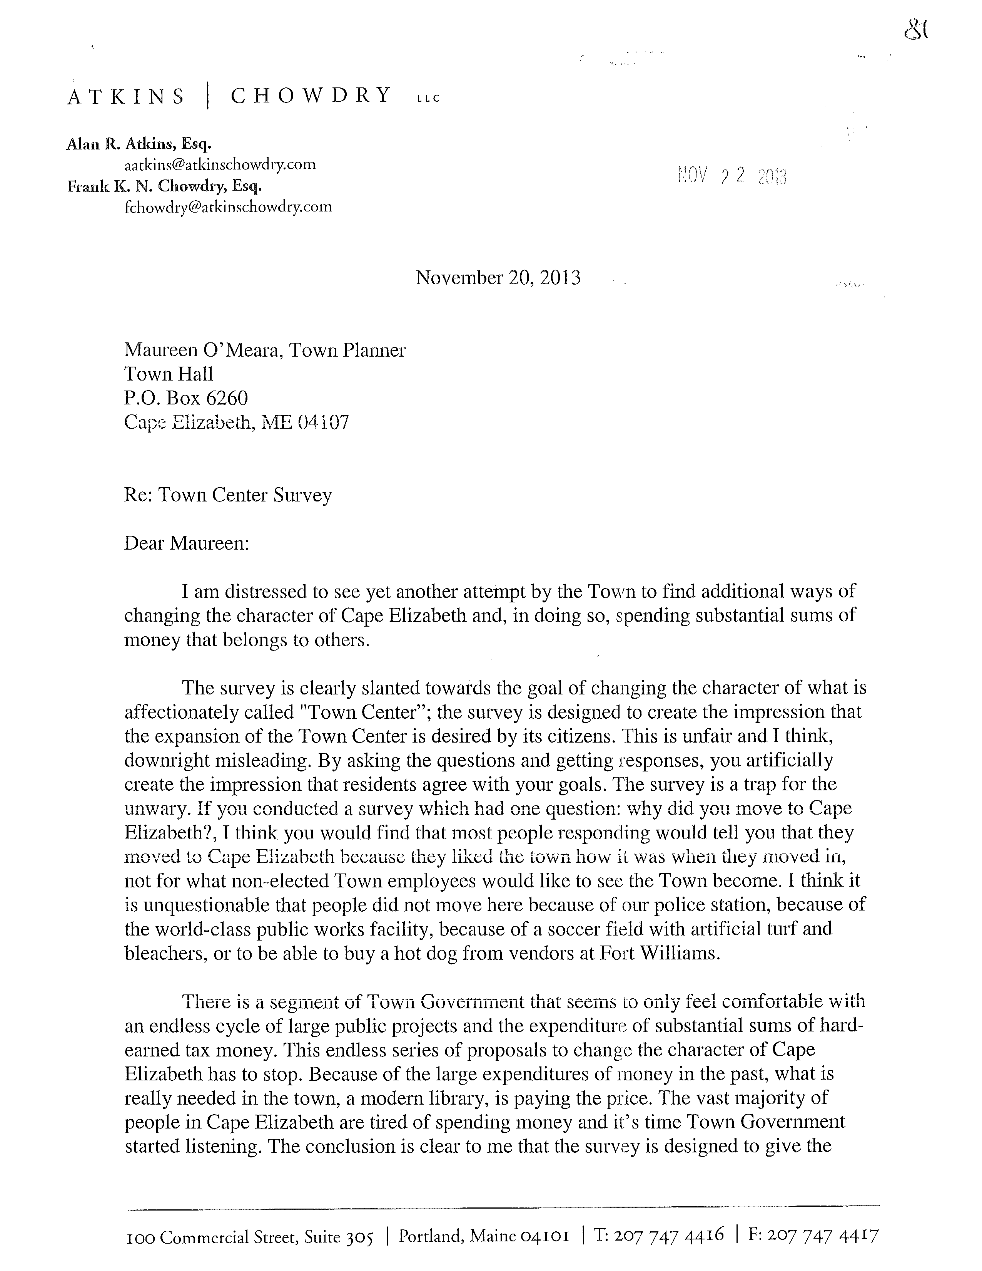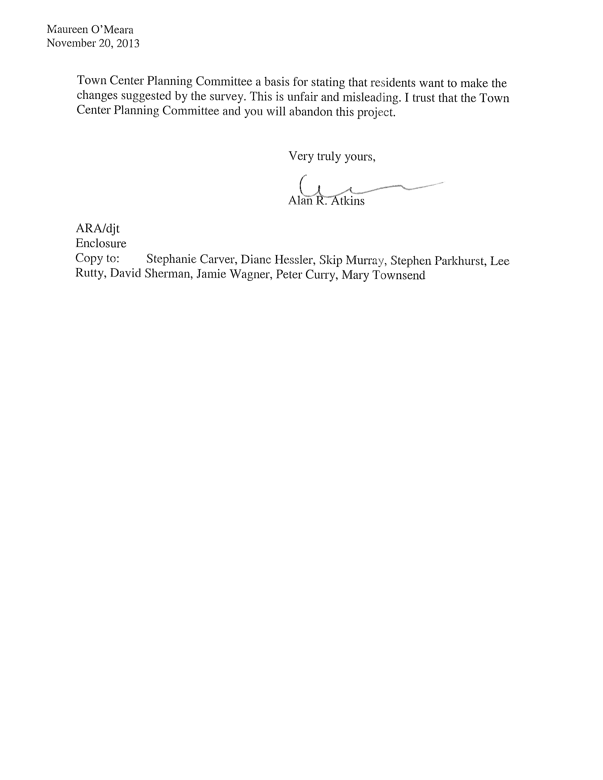

**Appendix E**

**Town Center Existing Properties Spreadsheet**

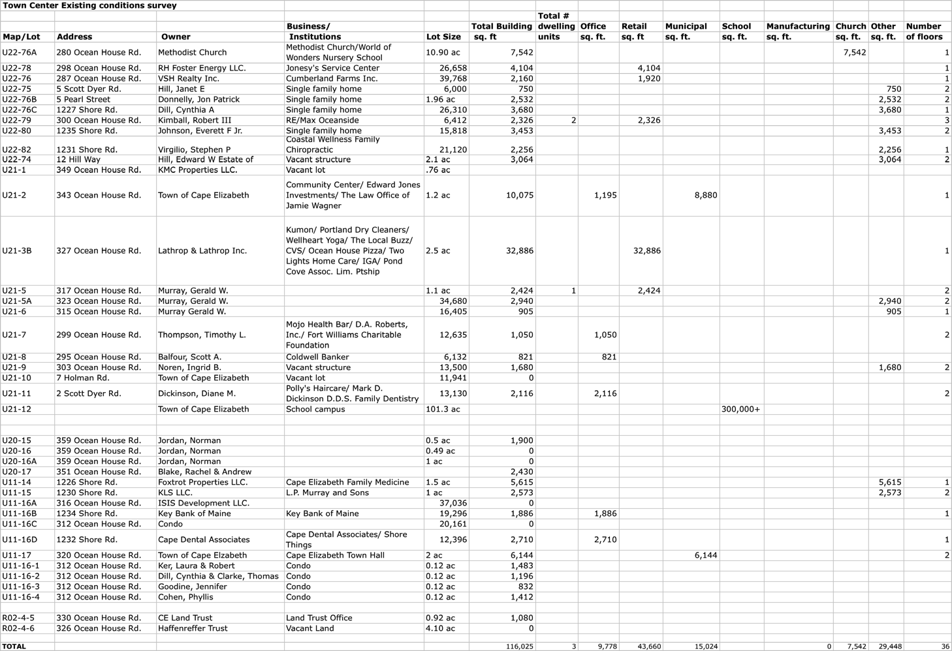**Appendix F**

**Town Center Infrastructure**

Roads

Route 77, locally known as Ocean House Rd, is the spine of the Town Center. This is the main road of the Town Center, and the only town arterial. Route 77 is the primary commuting conduit for Cape Elizabeth residents and also the major road to access the state parks/beach and Fort Williams Park. The most recent traffic count in the Comprehensive Plan indicates over 11,000 daily trips on Route 77 measured south of Scott Dyer Rd. South of Old Ocean House Rd, the trips declined to 7,200.

Scott Dyer Rd extends west from the Town Center’s major intersection and provides access to the library and northern end of the school campus where the Pond Cove Elementary and Middle School are located. West of Route 77, Scott Dyer Rd handles over 3,100 trips daily.

The southerly end of Shore Rd intersects with Route 77, forming the primary Town Center intersection. At Route 77, Shore Rd has over 3,500 trips daily.

The few additional roads in the Town Center serve almost exclusively local traffic. There are no “high accident” or “high traffic” locations in the Town Center and the roads are handling traffic at a level below their design capacity.

Sidewalks

The 1993 plan recommended that sidewalks be constructed on both sides of Route 77, Scott Dyer Rd and Shore Rd. The map below indicates where sidewalks currently exist and where sidewalks are proposed but not constructed.

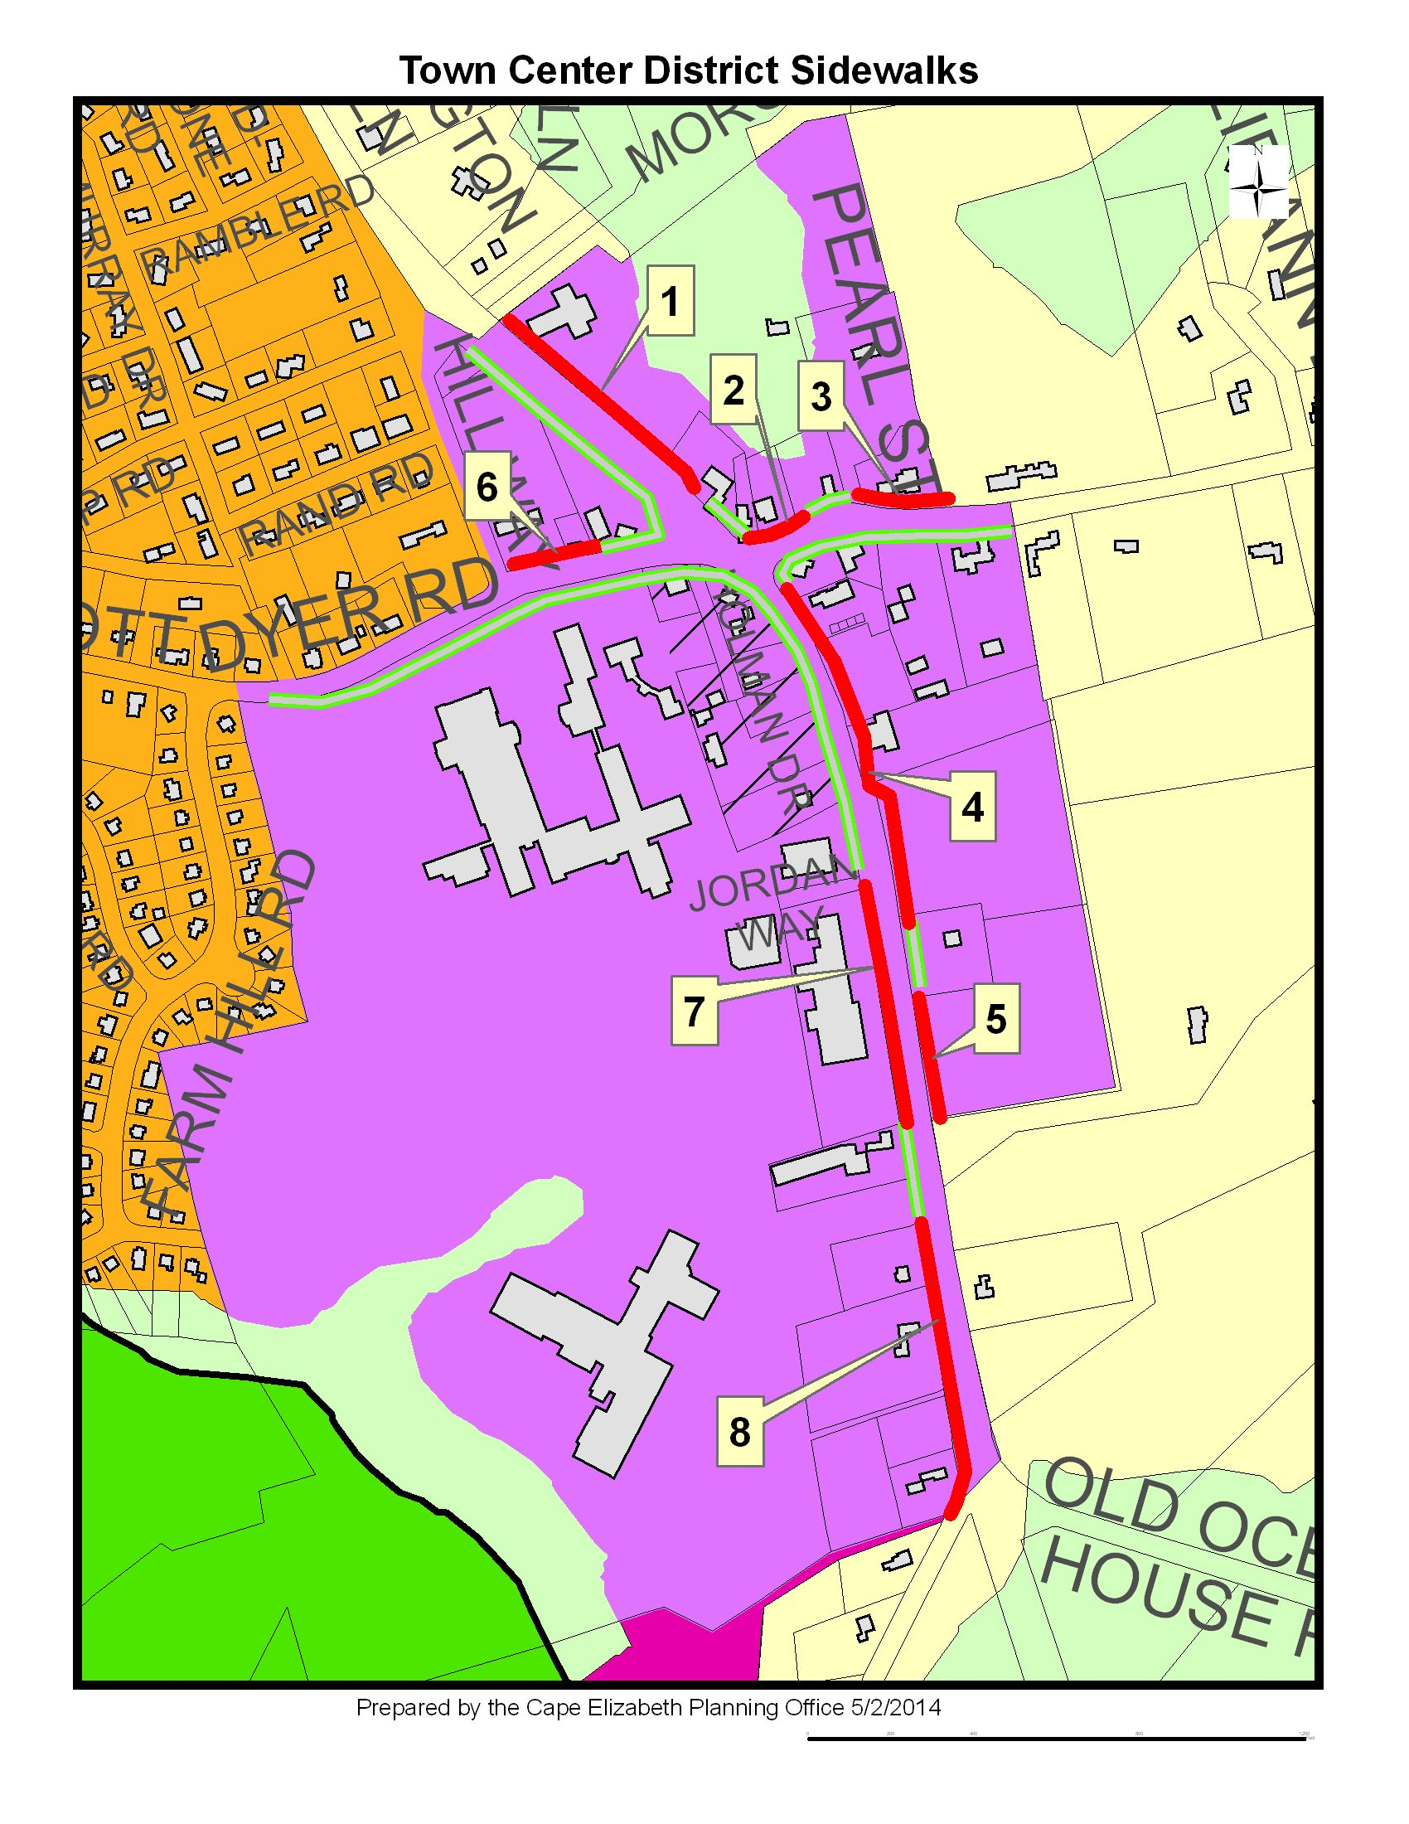

The chart below includes high-level, estimated costs to construct the missing town center sidewalk segments.

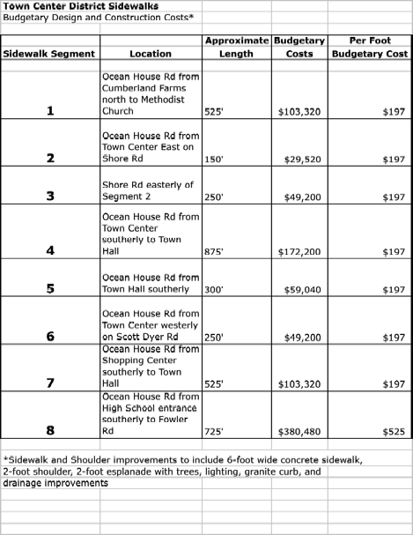

If the town proceeds with the original recommendation for sidewalks throughout the town center, an additional estimated 3,600 linear feet of sidewalk would need to be constructed. High-level cost estimates to complete the Town Center sidewalk network would cost in the range of 1 million dollars.

Other sidewalk improvements might include connections to nearby neighborhoods and are expanded upon below:

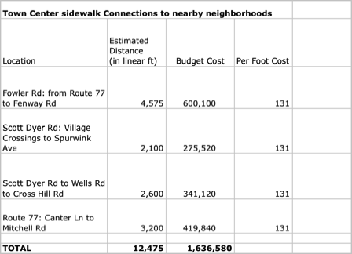

Stormwater

In 1995, with funding from the Casco Bay Estuary Project, the Town prepared a Town Center Stormwater Management Plan. The plan called for infrastructure improvements to collect stormwater and convey it through the school campus to discharge into the marsh. Best Management Practices, such as cleaning catch basins, sweeping roads and installing oil/grit separators were recommended. Some of this work, such as installing properly sized pipes on Middle School end of the school campus, was done in 1995. Vortechnic units, which help segregate grit, were installed at the outlets to the marsh, along with stormwater collection infrastructure when High School was renovated in 2004.

The original plan called for $1.2 million in infrastructure improvements. Since 1995, there has been a shift in best management practices for stormwater that emphasize reducing impervious surface and onsite stormwater quality controls. Prior to proceeding with further stormwater infrastructure improvements, the 1995 plan should be updated.

Public Sanitary Sewer

The Town Center is a designated Sewer Service area, which means that town center properties can be and are often required to be served by public sewer. A gravity public sewer line is located on the west side of Route 77, from Scott Dyer Rd to the Old Ocean House Rd. This line connects to a larger interceptor sewer line that runs westerly through the school campus and cross-country to the Southern Cape Treatment Plant on Spurwink Ave. Public sewer extends to the limit of the Town Center in Shore Rd and beyond the Town Center on Scott Dyer Rd. At the time of this report, the Town has capacity at the Southern Cape Treatment Plant to accommodate additional sanitary flows.

Public Water

The Portland Water District supplies public water to all properties in the Town Center for drinking water and fire suppression. The Scott Dyer Rd water line was installed in 1942 and 1948 and had a history of leaks dating back 10 years. The Portland Water District identified this as a priority project in their workplan and a segment in the Town Center was replaced with a new and larger pipe in 2009. Another priority project in their workplan is to clean and cement line approximately 11,000 feet of existing 8” main on Shore Rd from Scott Dyer Rd to 250’ south of Olde Colony Lane. A third project is to clean and cement line approximately 2,000 feet of existing 8” line in Ocean House Rd from Scott Dyer Rd to a point approximately 300 feet north of Maple Lane.

Utilities: Electric, Cable

As part of the 2007 Comprehensive Plan, Central Maine Power and Time Warner Cable were contacted regarding the adequacy of service and infrastructure in the town. Both utilities reviewed their respective Cape Elizabeth systems and determined them adequate at the time of that process.

Gas

The Town has considered the extension of a natural gas line to the town center at least once a decade. Each time, the town would need to pay more than one-half the cost of the infrastructure extension, as well as all the costs to convert existing systems. At this time, the town is again collecting information on the costs involved to make natural gas available and evaluating potential cost savings.

**Appendix G**

**Village Green Concept Plan**

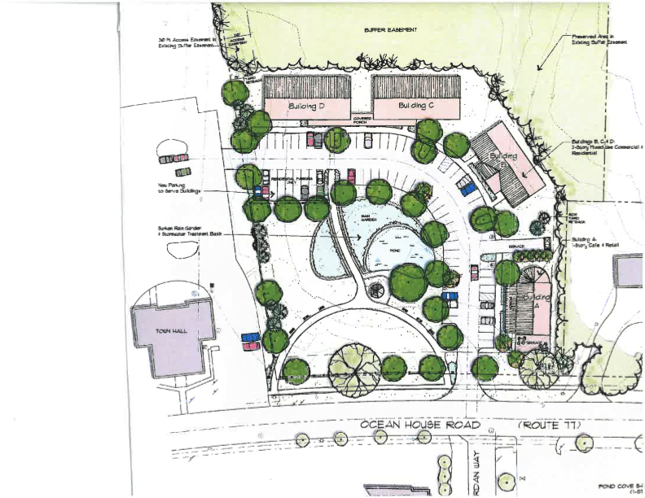**Appendix H**

**Sample Zoning Ordinance Text Amendment**

Sec. 19-6-4. **TOWN CENTER DISTRICT (TC)**

**D. Standards**

***1. Performance Standards***

i. Notwithstanding the provisions of Sec. 19-6-9, Resource Protection District, and Sec. 19-8-3, Resource Protection Performance Standards, an RP2 District wetland located on a lot in the Town Center District may be completely altered when the overall development includes a substantial public benefit, such as creation of a publicly accessible village green. The same overall development will also not be required to meet the maximum front yard setback for buildings located in the development. The overall development is subject to Site Plan Review by the Planning Board.

**Appendix I**

**Reference Materials**

•1993 Town Center Plan

•2007 Comprehensive Plan

•2007 Oest Associates Sidewalk construction estimates

•2012 Future Open Space Preservation Committee Final Report

•2013 Zoning Ordinance, Town Center Zoning District

•FY 2014/15 Proposed Capital Improvement Program

•Town Council Communication Strategy

•Planning Commissioners Journal, Winter 1996-97, “Our Vanishing ‘Third Places.”

•Planning Commissioners Journal, Summer 2001, “Building Codes Get Smarter.”

•Planning Commissioners Journal, Spring 2005, “Sizing up Downtown.”

•Planning Commissioners Journal, Summer 2005, “Downtown Hurdles.”

•Planning Commissioners Journal, Winter 2005, “Why Downtowns (Should) Matter to Planning Commissioners.”

•Planning Commissioners Journal, Spring 2006, “Creating the Missing Hub: How Today’s Suburbs Build Town Centers

•Planning Commissioners Journal, Fall 2006, “Recycling Main Street.”

•Planning Commissioners Journal, Summer 2009, “Libraries at the Heart of our Communities.”

•Planning Commissioners Journal, Summer 2010, “Turning Downtowns Around: Business Improvement Districts.”

•http://plannersweb.com, “How Façade Improvement Programs Can Benefit Your Community,” 2013.

•http://plannersweb.com, “Making Neighborhoods More Walkable-Part 2,” 2013

•http://plannersweb.com, “Pro-Forma 101:Part 2 - What Will it Cost to Build the Project,” 2013.

•http://plannersweb.com, “Pro-Forma 101: Part 3 - How Much Money will the Project Make for the Developer?” 2013.

•http://plannersweb.com, “Pro-Forma 101: Part 4 - Looking at Alternative Scenarios,” 2014.

•”Municipal Tax Increment Financing,” State of Maine, Department of Economic And Community Development, January 20, 2011.

•Walker, Philip, Downtown Planning For Smaller and Midsized Communities, American Planning Association, 2009.